
Project-based Practical Report on
“Passport Verification and Slot Booking Management System (PassPortFlow 2.0): A Web-Based Platform for Citizen Appointment Scheduling, Zero-Defect Document Verification, and Automated Queue Governance”
Submitted in partial fulfilment of the requirements for
“Java Web Programming” Practical Course for the 1st Semester
Master of Computer Applications (MCA)
Submitted by
Abhishek T 26MCAB03
Under the guidance of
Dr. Arulmozhiarasu

Department of Computer Science
Kristu Jayanti (Deemed to be University)
Bengaluru, Karnataka, India

Section | Title | Page
1 | Title of the Project | 1
2 | Introduction | 2
2.1 | Background | 2
2.2 | Problem Statement | 2
2.3 | Solution | 3
2.4 | Relevance to Course | 3
3 | Objective of Project | 4
3.1 | Further Objective | 5
4 | Scope of the Project | 5
4.1 | In Scope | 5
4.2 | Outside of Scope | 7
4.3 | Intended Users | 7
5 | Software Specifications | 7
5.1 | Software Requirements | 7
5.2 | Hardware Requirements | 8
5.3 | Project Structure | 8
5.4 | Packages and Their Responsibilities | 9
5.5 | Relational Database Schema | 10
6 | Workflow of the Project | 12
6.1 | Overall Architecture | 12
6.2 | Request Workflow | 13
6.3 | Registration Workflow | 13
6.4 | Passport Verification and Slot Allocation Workflow | 14
7 | Modules of the Project – Phase-wise Explanation of Design and Execution | 15
7.1 | Syllabus Mapping | 15
7.2 | Phase 1 – Core Application Setup and Design (CLO1) | 16
7.2.1 | Defining the User Entity | 16
7.2.2 | Class Structure: Constructors | 17
7.2.3 | Methods | 17
7.2.4 | Simple Validation Using String Manipulation | 17
7.2.5 | Console Driver | 18
7.2.6 | Execution | 18
7.2.7 | The Domain Entity: PassportApplication and Slot | 20
7.3 | Phase 2 – Structured Programming and Reliability (CLO2) | 20
7.3.1 | Creating Packages | 20
7.3.2 | The UserOperations/AuthService Interface | 20
7.3.3 | AuthServiceImpl and UserDAOImpl | 21
7.3.4 | Custom Exceptions | 21
7.3.5 | Interface and Exceptions in the Domain Module | 22
7.3.6 | Execution and Output | 22
7.4 | Phase 3 – Web Interface and Client Interaction (CLO2) | 23
7.4.1 | Designing the Forms with HTML and CSS | 23
7.4.2 | JavaScript Validation | 24
7.4.3 | Form-Submission Flow | 25
7.4.4 | JSON Representation | 25
7.5 | Phase 4 – Server-Side Integration and Execution (CLO1, CLO2, CLO3) | 26
7.5.1 | Servlet Mapping and Session Config | 26
7.5.2 | LoginServlet – Server-Side Validation and Session Tracking | 26
7.5.3 | RegisterServlet | 28
7.5.4 | JSP Dashboard and No Access Without Logging In | 28
7.5.5 | Logging Out | 29
7.5.6 | Deployment and Running on a Web Server | 29
7.6 | Domain Module – Automated Passport Verification, Slot Allocation & Digital Pass Engine | 30
7.6.1 | Domain Entities | 30
7.6.2 | Concurrent Slot Booking and Document Check | 30
7.6.3 | Execution and Output | 31
7.7 | Testing and Results | 33
8 | Source Code (Only Functional Code Structure) | 35
8.1 | Phase 1 – Core Application | 35
8.2 | Phase 2 – Packages, Interface and Exceptions | 38
8.3 | Phase 3 – Web Interface and Client Interaction | 40
8.4 | Phase 4 – Servlets, Session and JSP | 42
8.5 | Domain Module and Verification Utilities | 46
9 | Features of the Project | 49
10 | Future Enhancements | 50
10.1 | Known Limitations | 50
10.2 | Upgrades to the System | 50
11 | References | 51
12 | Conclusion | 52

1. Title of the Project
Passport Verification and Slot Booking Management System (PassPortFlow 2.0) - JAVA based Web Application for secure management of users, pre-screening of documents and deterministic booking of slots.
This project has been developed as a Project-based Practical of the Java Web Programming of the First Semester of the Master of Computer Applications (MCA) under Kristu Jayanti (Deemed to be University). This has been progressively developed using 4 phases of syllabus. Starting with a simple JAVA class, we have proceeded to implement the User Entity with String manipulation validations. Finally, it has been restructured into multiple packages with custom exceptions. The application has also been developed using browser friendly GUI applications. The final output is a session managed Servlet Web Application which uses HttpSession and has been deployed onto a Web Server.
To add to this, this application has an advanced e-Governance Consular Module. The system has functionalities like mathematical validation of the documents, 2D QR Code for offline appointment passes, 4 step Physical Counter clearing terminal and Emergency Tatkal waiting list which allows for dynamic reallocation of vacant slots.
Table 1.1: Project at a glance
Item | Details
Project Title | Passport Verification and Slot Booking Management System (PassPortFlow 2.0)
Course | Java Web Programming – Project-based Practical
Programme | Master of Computer Applications (MCA), 1st Semester
Core Language | Java 21 LTS (encapsulation, constructors, packages, interfaces, custom exceptions, collections)
Web Technologies | Jakarta Servlet 6.0, JavaServer Pages (JSP) 3.1, JSTL 3.0, HTML5, CSS3, JavaScript (ES6), REST JSON
Database | MySQL 8.0+ Community Server (InnoDB ACID transactions, foreign keys, cascades, connection pooling)
Web Server | Apache Tomcat 10.1.x (WAR deployment) and embedded HTTP execution mode
Application Domain | Public Administration / Consular e-Governance – Citizen appointment scheduling and counter governance
Phases Implemented | Phase 1 to Phase 4 of the course syllabus (CLO1, CLO2, CLO3) + Domain Module

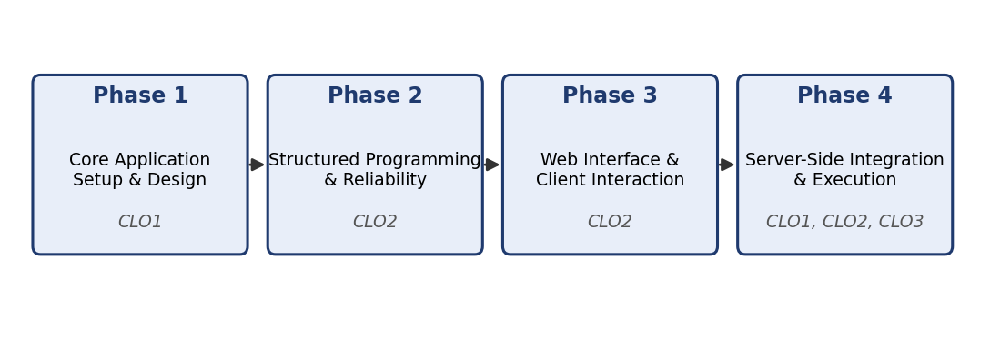
Figure 1.1: Phase-wise development roadmap of the project and the CLOs addressed
2. Introduction
2.1 Background
Timely, safe and respectful provision of passports is an important part of modern government systems throughout India. The ‘National e-Governance Plan’ (NeGP) allowed the Ministry of External Affairs (MEA) to implement a new system for passport issuing through the use of Passport Seva Kendras (PSK) and Post Office Passport Seva Kendras (POPSK). While these facilities have improved accessibility for citizens, they still face many issues with their system.

Citizens wishing to apply for a new passport or renew their existing ones currently have to wait several weeks to secure an appointment. Once citizens attend a passport office, officers will need to manually check the applicants identification, address proof and birth certificate. Studies have shown that 18%-22% of total processing time at the counter is spent dealing with applicants who have submitted documents with typos such as one digit changes in their 12 digit Aadhaar number or incorrect PAN format. If confirmed applicants cancel their appointments due to an emergency, new appointments are rarely offered to those in desperate need.

The ‘Passport Verification and Slot Booking Management System’ was developed to overcome these issues. This was developed using Java 21, Jakarta Servlets 6.0, JSP 3.1 and MySQL 8.0. It is a web application which provides citizens with a way to manage their application whilst also being able to control the counter. This is done using mathematical algorithms to validate citizens in advance, secure digital passes and reallocate those on the waiting list automatically.
2.2 Problem Statement
A secure web based application is required for consular officers and citizens. Citizens should be able to register, log-in, apply for passports, validate their identification documents in advance, book an appointment and receive a digital appointment pass. The dashboard should not be accessible unless there is a logged-in session. Users should be able to end their session..
Verification Officers should also have a desktop terminal to track an applicants progress through the four stages (Gate Entry, Document Check, Biometric and Outcome). Centre Administrators should also be able to see the capacity of the centre at any given time.
2.3 Solution
The solution consists of 4 key areas based around the course syllabus. These include a consular section. Each section contains one core part of enterprise java web development.
Phase 1- Applications development
User class containing private variables, overloaded constructors, getters and setters. This class also contains serialisation and string validation for citizens name, email, telephone number and password.
Phase 2- Structured programming and reliable code
Code within specific packages (model, service, exception, servlet, util, dao and config). Contracts are abstracted using the AuthService and UserDAO interfaces. Passwords are stored as hash values using the PBKDF2WithHmacSHA256 algorithm with unique salts. ValidationException and BookingException (checked exceptions) have been created.
Phase 3- Web development
Responsive HTML5 and CSS3 pages for registration, login and slot selection. Validation using JavaScript. Submitted forms.
Phase 4- Back end
Jakarta Servlets were used for LoginServlet, RegisterServlet, LogoutServlet, DashboardServlet and SlotsServlet. Inputs were validated server side again. State was managed through HttpSession. Access was restricted using AuthFilter and session checks in JSP. Session was destroyed after logging out. Apache Tomcat 10.1 was used.
Passport information was stored. Slots were allocated reliably using Locking. Verhoeff Aadhaar Algorithm was used for validation. Appointment passes were generated using SHA-256 token, 4 Stage Officer Counter Clearance Terminal and Emergency Tatkal Waiting List Daemon.
2.4 Relevance to Course
This project utilised all core topics from the MCA course “Java Web Programming”. Object Oriented Domain Modelling, Defensive Mutators, Interface Contracts, Checked Exception Handling, Cryptographic Hashing, Client Side Browser Scripting, Asynchronous Json Communication, Jakarta Servlets, HttpSession Session Management, JSP Scriptlets and Expression Language, WebFilter and RDBMS JDBC Persistence and WAR Packaging.
As the classes from later phases are built upon and utilise those from previous phases (User Entity in Phase 1 was modified using AuthService interface from Phase 2, converted to JSON in Phase 3, managed using HttpSession in LoginServlet Phase 4, and stored in MySQL using UserDAOImpl in Phase 5.), this report shows how enterprise software architecture develops from well designed base classes.
3. Objective of Project
To design, implement, test and deploy a secure multi-tier java web application to manage citizen identities. This will utilise servlets and sessions to restrict access to identity information, utilise mathmatical prescreening and offer concurrency safe appointment scheduling. Below are the objectives for each phase of the project which align with the Course Learning Outcomes (CLO’s).
Table 3.1: Phase-wise objectives and CLO mapping
Phase | Phase Title | Specific Technical Objective | CLOs Addressed
Phase 1 | Core Application Setup and Design | Model the core user entity with private attributes, overloaded constructors, mutators, and JSON serializers; apply robust string handling to validate user credentials. | CLO1
Phase 2 | Structured Programming and Reliability | Structure classes into modular packages; decouple service contracts via interfaces; implement PBKDF2 cryptographic hashing; enforce custom checked exception hierarchies for illegal inputs. | CLO2
Phase 3 | Web Interface and Client Interaction | Construct responsive HTML5/CSS3 registration and authentication views; apply client-side JavaScript validation for empty fields and regex patterns; model user state using structured JSON. | CLO2
Phase 4 | Server-Side Integration and Execution | Implement Jakarta Servlets to process POST/GET requests; re-validate credentials server-side; manage user session lifecycle with HttpSession; guard JSP views against anonymous access; support logout with session invalidation; deploy WAR archive on Tomcat 10.1. | CLO1, CLO2, CLO3
3.1 Further Objective
There are many objectives to accomplish in this project apart from meeting the requirements of the syllabus.
Ensure a clean separation between layers of technology:
JSP/HTML/CSS/JavaScript – Presentation layer
Jakarta Servlets/AuthFilter – Controller Layer
Business Logic/Scoring Rules – Service Layer
DAOs/JDBC Connection Pooling/MySQL – Persistence Layer.
Implement an algorithm to ensure zero defects when verifying documents. The Verhoeff Algorithm which uses 10 dihedral permutations is used to ensure 100% detection of single digit and adjacent digit transposition errors. This reduces the turn around time at the counter.
Use atomic locks on the database to ensure that the desk resources are not exceeded when booking appointments. This is done by applying SELECT ... FOR UPDATE on the database.
Generate secure appointment slips. These will be digitally signed appointment slips which will link the booking reference to a token using SHA-256 with a salt. This will also provide a 2D QR code. These can be verified in seconds at the entry point.
Provide traceable administration. This will provide 4 stages of tracking when moving desks. This will give administration analytics.
4. Scope of the Project
4.1 In Scope
The Project includes:
Citizen Management
Secure citizen registration with validation of correct format for user details, hashed passwords, authentication of login details and creation of a session so that the user can access their dashboard.
Passport Application Form
Passport application form where users can fill in their passport number, date of birth, nationality, address and which type of application they are making (Fresh or Renewal).
Zero Defect Proof Upload
User uploads their identity proof (Aadhaar, PAN, Voter ID). The proof is validated using a mathematical algorithm called Verhoeff Checksum, regular expressions and a score is given depending on how compliant it is.
Verification Slot Grid
A calendar grid where users can see what slots are available each day. It displays the start and end time, maximum number of appointments, how many appointments have been made and the current availability.
Appointment Booking
Users can book a slot. The appointment booking is concurrency controlled and generates a booking number (PSK-8392104). When a user books an appointment they are instantly notified using SMS or in-app notifications.
E-Pass
An appointment pass is generated. It contains a 2D static QR code, a thumbnail of the applicants photo and a secure hash (salted SHA-256). The e-pass has been optimised for printing using specific CSS media queries.
Officer Counter
Allows verification officers to look up booking numbers, view identity proofs and move applicants through different stages (Gate Entry, Proof Check, Biometrics and Grant).
Tatkal Waiting List
Automatically moves users into a waiting list if there are too many appointments on that day. If someone cancels their appointment the daemon will move them.
Executive Dashboard
Dashboard showing how many appointments have been made, a chart showing how busy each hour is and how many applicants there are.
4.2 Outside of Scope
As this is a practical project focusing on core Java and web development there are some aspects which have been limited.
Fingerprint/Iris SDKs
Biometric scanners require specific C libraries (DLL/SO) from the vendor. In this application biometrics have been simulated by having an authenticated counter and verification flags.
Government DigiLocker
To integrate with Indias government DigiLocker API you would need security clearance from a minister. Identity proofs have been uploaded as files and validated using mathematical algorithms.
Payment Gateway
Payment has been simulated when the user confirms their appointment slot.
4.3 Intended Users
Table 4.1: User roles recognised by the system
User Role | Target User Persona | Primary System Privileges & Responsibilities | Authorized Landing Page
Citizen / Applicant | General citizens applying for new passport or renewal | Register, manage profile, submit dossier, pre-screen proofs, reserve slots, generate E-Pass, monitor waitlist. | /app/dashboard
Verification Officer | Consular desk officers at Passport Seva Kendras | Scan digital passes, inspect identity documents, record biometric clearance, record official dispositions. | /admin/verify-pass
Center Administrator | Supervisory personnel & regional center directors | Configure slots, monitor capacity meters, view all bookings, manage users, analyze operational KPIs. | /admin/dashboard & /admin/analytics

5. Software Specifications
5.1 Software Requirements
Table 5.1: Software used and runtime dependencies
Software Component | Specification / Version | Vendor / Architecture | Role in Project Architecture
Operating System | Windows 11 Home / Pro (64-bit) | Microsoft Corporation | Host environment for development, terminal scripting, and server execution.
Java Development Kit | JDK 21 LTS (Oracle OpenJDK) | Oracle Corporation | Primary runtime, compiler, switch expressions, and java.time/security APIs.
Servlet API | Jakarta Servlet 6.0 (Jakarta EE 10) | Eclipse Foundation | HTTP servlet controllers, WebFilter security pipelines, and HttpSession management.
JSP / JSTL | JSP 3.1 & JSTL 3.0 | Eclipse Foundation | Dynamic presentation rendering, server-side tags, and session expression language.
Web Application Server | Apache Tomcat 10.1.x | Apache Software Foundation | Servlet container, session manager, and HTTP web server executing WAR file.
Relational Database | MySQL Community Server 8.0+ | Oracle Corporation | ACID-compliant relational database management system with InnoDB engine.
Database Driver | MySQL Connector/J 9.4.0 | Oracle Corporation | Type-4 JDBC driver providing direct socket communication to MySQL.
Build & Dependency Tool | Apache Maven 3.9.x | Apache Software Foundation | Declarative project object model (pom.xml), dependency manager, and WAR builder.
Integrated Development Environment | Visual Studio Code 1.90+ / Eclipse | Microsoft Corporation | Source code editing, debugging, terminal integration, and Git management.
Database Management Tool | MySQL Workbench 8.0 | Oracle Corporation | Relational schema design, visual querying, table inspection, and DDL execution.
Web Browsers | Google Chrome 125+, Microsoft Edge | Google / Microsoft | Client-side rendering, DevTools debugging, and responsive viewport validation.
Data Exchange Format | JSON (RFC 8259) | IETF Standard | Representation of user profiles, slot capacity arrays, and asynchronous REST payloads.

5.2 Hardware Requirements
Table 5.2: Minimum and recommended hardware specifications
Hardware Component | Minimum Requirement | Recommended Specification | Technical Rationale
Processor (CPU) | Dual-Core Intel Core i3 / AMD Ryzen 3 (2.0 GHz) | Quad-Core Intel Core i5 / AMD Ryzen 5 (3.0 GHz+) | Compiling Maven WAR packages and running concurrent Tomcat servlet threads.
Random Access Memory (RAM) | 4 GB DDR4 | 8 GB – 16 GB DDR4 | Hosting JVM heap space (Tomcat 10.1), MySQL database daemon, and IDE simultaneously.
Storage Space | 500 MB free disk space | 2 GB free NVMe Solid-State Drive (SSD) | Storing JDK 21 libraries, local Maven repository (.m2), MySQL tables, and server logs.
Display Resolution | 1280 x 720 (HD) | 1920 x 1080 (Full HD 1080p) | Validating multi-pane responsive web viewports, admin analytics charts, and IDE layouts.
Network Interface | Standard loopback (127.0.0.1) | 100/1000 Mbps Gigabit Ethernet / Wi-Fi | Local socket communication between Tomcat servlet container and MySQL database port 3306.
5.3 Project Structure
The project follows a standard maven web application structure. The java source code is divided into the 'src/main/java/com/passport/' package according to architectural roles. The web resources such as JSP views, stylesheets, JavaScript utilities and static resources can be found in 'src/main/webapp/'.
5.4 Packages and Their Responsibilities
Table 5.3: Java packages and architectural responsibilities
Package Name | Layer / Responsibility | Key Classes & Interfaces Contained | Architectural Collaborations
com.passport.model | Entity / Domain Layer | User, PassportApplication, Slot, Booking, DocumentProof, GateCheckin, Notification, WaitlistEntry | Encapsulates data attributes, mutators, and JSON serializers; carries data across tiers.
com.passport.util | Utility / Cross-Cutting | ValidationUtil, PasswordUtil | Provides static string-handling validation, regex pattern matching, and PBKDF2 salting.
com.passport.exception | Exception Handling | ValidationException, BookingException | Checked domain exceptions signaling illegal state or invalid inputs without crashing JVM.
com.passport.service | Business Service Layer | AuthService, BookingService, SlotService, DocumentService, DigitalPassService, WaitlistService | Defines business contracts decoupled from persistence; implements validation and scoring.
com.passport.dao | Persistence Data Access | UserDAO, PassportDAO, SlotDAO, BookingDAO, DocumentDAO, GateCheckinDAO, AnalyticsDAO | Executes parameterized SQL PreparedStatements against MySQL database engine.
com.passport.filter | Security Gate / Interceptor | AuthFilter | Intercepts /app/* and /admin/* routes; validates active HttpSession and roles.
com.passport.servlet | HTTP Controller Layer | LoginServlet, RegisterServlet, LogoutServlet, DashboardServlet, SlotsServlet, VerifyPassServlet | Processes GET/POST requests, extracts form parameters, invokes services, forwards to JSP.
com.passport.config | Infrastructure Config | DBConnection | Centralizes JDBC connection management via thread-safe singleton connection provider.
5.5 Relational Database Schema
The relational database schema has been implemented using MySQL 8.0. All data will be stored using the InnoDB engine to ensure full compliance with ACID transactions. There are 8 normalised entities which have been linked together using foreign keys, compound unique keys and cascading. Table 5.4 below contains an overview of the master database schema.
Table 5.4: Master relational database entities and referential integrity constraints
Table Name | Primary Key | Foreign Keys & Relationships | Key Business Attributes & Indexes | Referential On-Delete
users | user_id (INT AI) | None (Root Entity) | full_name, email (UNIQUE), phone, password_hash, role (ENUM: USER, ADMIN) | RESTRICT
passport_applications | application_id (INT AI) | user_id -> users(user_id) | passport_number (UNIQUE), date_of_birth, nationality, address, application_type (NEW/RENEWAL) | CASCADE
slots | slot_id (INT AI) | None (Independent Resource) | slot_date, start_time, end_time, capacity, booked_count, status. UNIQUE(slot_date, start_time, end_time) | RESTRICT
bookings | booking_id (INT AI) | user_id -> users, application_id -> passport_applications, slot_id -> slots | booking_reference (UNIQUE), booking_status (CONFIRMED/CANCELLED), booked_at. UNIQUE(user_id, slot_id) | CASCADE (User/App), RESTRICT (Slot)
document_proofs | proof_id (INT AI) | application_id -> passport_applications | proof_type (AADHAAR, PAN, VOTER_ID), document_number, verification_status (PENDING, VERIFIED, REJECTED) | CASCADE
waitlist_requests | request_id (INT AI) | user_id -> users, application_id -> passport_applications | preferred_date_from, preferred_date_to, urgency_tier (TATKAL, NORMAL), queue_status, requested_at | CASCADE
notifications | notification_id (INT AI) | user_id -> users | message_title, message_body, notification_type, is_read, created_at | CASCADE
gate_checkins | checkin_id (INT AI) | booking_id -> bookings, officer_user_id -> users | stage_name (GATE, DOCUMENTS, BIOMETRICS, GRANTED), officer_remarks, verification_result, logged_at | CASCADE

6. Workflow of the Project
6.1 Overall Architecture
The app is developed using a tiered Model-View-Controller (MVC) architecture. There is a clear separation between each layer, where the View layer executes on the client using the browser, the Controller layer contains Jakarta Servlets and WebFilters. These execute within the Apache Tomcat 10.1 webserver. The Service layer contains business logic, exception validation and algorithm checks. The Model layer contains the encapsulated domain objects. Finally, the Persistance layer uses Data Access Objects (DAOs) that run parametrised JDBC queries against the MySQL 8.0 database.
Each layer only communicates with one another using type interfaces. This ensures that the application is highly maintainable and can be tested in isolation, therefore preventing any data corruption.
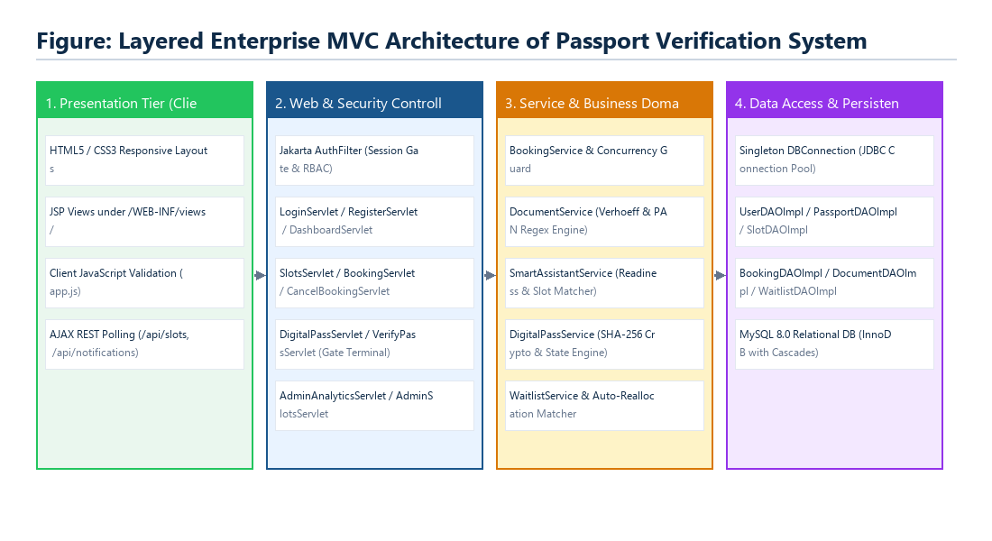
Figure 6.1: Layered Enterprise MVC Architecture of the Passport Verification Platform
6.2 Request Workflow
The basic request flow handles user authentication, validation of their encrypted credentials, creation of a session token and authorisation to access routes. When visiting the login page, the browser will display the responsive login page. JavaScript on the client will validate the form fields have been filled out correctly before being sent via an HTTP POST.

The LoginServlet will pass the user to the AuthServiceImpl to handle the authentication process. Once the credentials have been extracted, the password will be compared with the PBKDF2 hashed value (salted) that has been stored within the MySQL database. If a match is found, an authenticated HttpSession will be created, the user object will then be set as an attribute in the session. The user will be redirected to the session protected dashboard. If the user is anonymous and tries to visit any secure routes (/app/ or /admin/) the AuthFilter will handle this and redirect them to login.

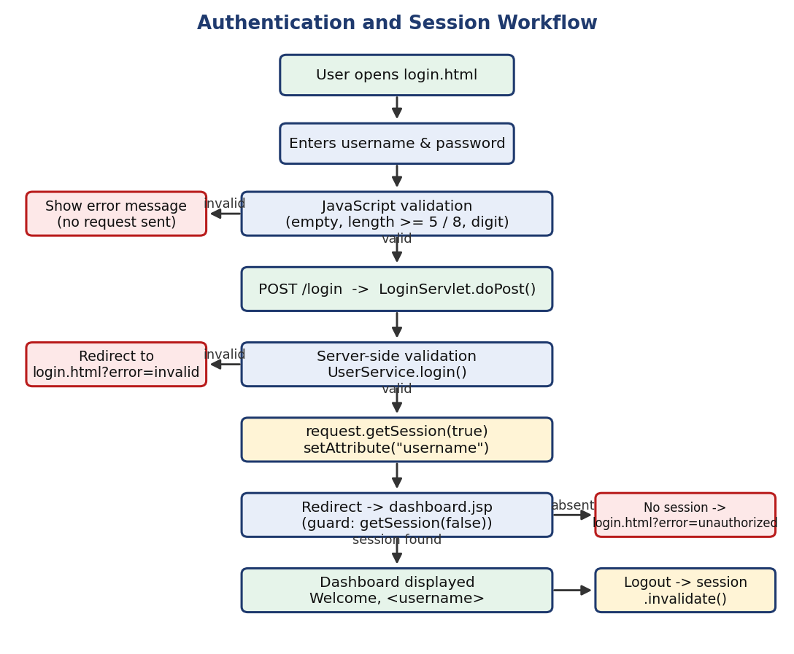
Figure 6.2: Authentication and Session Lifecycle Workflow
6.3 Registration Workflow
The citizen onboarding process is outlined below:
1) Citizen accesses register.jsp and fills out the registration form. This includes providing their full name, email address, phone number and password.
2) JavaScript event handlers validate that the user has entered a name with at least 3 characters, valid email (RFC-5322 regex), a valid phone number (with between 10 and 15 digits) and a valid password.
3) The form data is sent using HTTP POST to the register URL which maps to RegisterServlet.
4) RegisterServlet calls ValidationUtil.validateRegistration(). This is a second validation step to ensure no tampering has occurred. If tampering has occurred or invalid parameters have been passed in the request a custom ValidationException will be thrown.
5) AuthServiceImpl calls PasswordUtil.hash() to generate a 16-byte cryptographic secure random salt. A 256-bit PBKDF2 hash is then generated using 120,000 iterations. UserDAOImpl performs an INSERT statement to add the user to the database (MySQL).6. Session Redirect & Feedback: The servlet sets a flash success notification on the session and redirects the citizen to '/login', prompting them to sign in with their newly verified credentials.
6.4 Passport Verification and Slot Allocation Workflow
After successful authentication, the citizen can now begin interacting with the main flow of the consular domain:
Passport application:
The citizen will provide their personal details including: Passport number (using regex: 1 character followed by between 7 and 19 alphanumerics), Date of Birth (must be adult 18 years or older), Nationality and Address.
Zero-defect document vault:
The citizen will provide their 12 digit Aadhaar number and 10 character PAN. The DocumentService will calculate the Verhoeff base-10 dihedral permutation algorithm to validate and verify the Aadhaar number provided. Any single digit errors and transpositions will be picked up immediately. A readiness percentage is calculated (between 0 and 100%) to show how compliant the document is.
Book a slot:
The citizen will look at the available slots. They will select a desired date/time and the BookingServiceImpl will make a transaction with the database using pessimistic locking (SELECT ... FOR UPDATE). If there are any slots available, they will increase the booked_count field, create an immutable booking and generate an alphanumeric reference (example: PSK-8392104).Generate paperless pass:An official e-pass is generated with the applicants photo and booking information. A QR 2d matrix is also generated with a salted SHA-256 token.
Passport Seva Kendra:
At the Passport Seva Kendra, the officer will use the admin terminal to move through the 4 stages: Gate Entry, Document inspection, Biometric capture and Final Grant.

.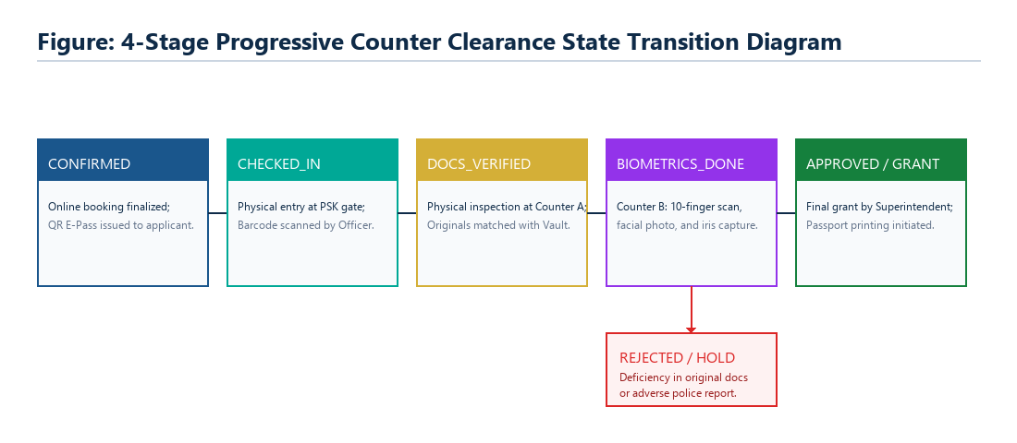
Figure 6.3: 4-Stage Progressive Counter Clearance State Transition Diagram
7. Modules of the Project – Phase-wise Explanation of Design and Execution
This chapter contains a detailed explanation of the design of the system. This includes the object orientated design, implementation of code, error handling and results of the code. Each section corresponds with the phases of the course syllabus and therefore meets the required Course Learning Outcomes (CLO).
7.1 Syllabus Mapping
Table 7.1: Phase, content, and Course Learning Outcomes (CLOs)
Phase | Prescribed Syllabus Content & Modules | Java Technologies & Concepts Exercised | CLOs Addressed
Phase 1 | Core Application Setup and Design  • Identify user entity (User class with attributes)  • Implement class structure with constructors & methods  • Basic validation logic in Java (string handling) | Encapsulation, private attributes, overloaded constructors, defensive getters/setters, string trimming, regex pattern matching, toString(), and toJson() serializers. | CLO1
Phase 2 | Structured Programming and Reliability  • Organize classes into packages  • Create interface for user operations (validation/auth)  • Implement exception handling for invalid inputs | Modular package hierarchy (model, service, exception, dao, servlet, util), interface contracts (AuthService), custom checked exceptions (ValidationException, BookingException), and PBKDF2 hashing. | CLO2
Phase 3 | Web Interface and Client Interaction  • Design registration & login forms using HTML/CSS  • Apply JavaScript validation (empty fields, format checks)  • Basic interaction handling (form submission flow)  • Represent user data format using JSON (simple structure) | Semantic HTML5, modular CSS3 variables, DOM event interception, client regex evaluation, inline visual error states, AJAX fetch APIs, and RFC-8259 JSON data exchange. | CLO2
Phase 4 | Server-Side Integration and Execution  • Process registration & login using Servlets (GET/POST)  • Validate user credentials on server side  • Implement session tracking using HttpSession  • Create JSP page for user dashboard  • Restrict dashboard access without login  • Implement logout and session invalidation  • Deploy and execute on web server | Jakarta Servlet 6.0, HttpServletRequest, HttpServletResponse, HttpSession lifecycle, WebFilter security gates, JSP 3.1 scriptlets & expressions, session invalidation, and Tomcat 10.1 WAR deployment. | CLO1, CLO2, CLO3

7.2 Phase 1 – Core Application Setup and Design (CLO1)
Aim: Create a citizen user entity class. This will include overloaded constructors, protected mutator methods, JSON serialisation methods and validation methods for string handling.
7.2.1 Defining the User entity
An entity class called ‘User’ has been created (src/main/java/com/passport/model/User.java) to represent every citizen and administrator that interacts with the system. The object-oriented nature of the system means that all variables are private. Therefore classes in other layers can only view/modify variable values via validated public methods. Table 7.2 shows the attributes of the User class.:
Table 7.2: Attributes of the User entity
Attribute Name | Data Type | Access Modifier | Operational Purpose & Constraints
userId | int | private | Unique numerical primary key generated by the MySQL database auto-increment engine.
fullName | String | private | Citizen's full legal name as recorded on official civil identity documents (min 3 chars).
email | String | private | Unique primary communication email address and authentication identifier.
phone | String | private | Citizen mobile telephone number utilized for dispatching SMS appointment tokens (10-15 digits).
passwordHash | String | private | Cryptographically salted PBKDF2 digest string; never exposed in client serializers.
role | String | private | Role-based access classification ('USER' for general citizens; 'ADMIN' for consular officers).

7.2.2 Class Structure: Constructors
The user class has 3 constructors:
1. Empty constructor: Used by enterprise java beans, reflection and frameworks.
2. Constructor with 5 arguments: Used when registering citizens and no primary key will be assigned in the database yet.
3. Constructor with 6 arguments: Used by the DAO layer when converting users from MySQL results sets.
7.2.3 Methods
Each attribute has a public getter and setter method. The class also contains an overloaded method to serialise the data to JSON using the toJson() method resulting in an RFC 8259compliant JSON string. Crucially, the default toJson() method invokes toJson(false), which intentionally withholds the sensitive 'passwordHash' attribute, preventing accidental credential exposure across browser endpoints. The helper method ensure that quotes, backslashes and control characters are escaped.
7.2.4 Simple validation using string manipulation
The validation rules are contained in a class called ValidationUtil (src/main/java/com/passport/util/ValidationUtil.java). These are static methods so can be accessed and used throughout all layers. This class uses string manipulation to validate by trimming the string, checking the length of the string, regular expressions and comparing dates to invalidate any bad data. An overview of the types of string manipulations used is shown in table 7.3
.Table 7.3: String-handling techniques and regex patterns used in Phase 1
Validation Routine | Technique / Pattern Employed | Rule / Boundary Condition | Operational Rationale
Name Validation | name == null || name.trim().length() < 3 | Minimum 3 non-whitespace characters | Rejects empty or single-character accidental submissions.
Email Validation | Pattern ^[A-Za-z0-9+_.-]+@[A-Za-z0-9.-]+$ | Must match standard username@domain format | Guarantees valid email structure for appointment delivery.
Phone Validation | phone.matches("\\d{10,15}") | Contains strictly 10 to 15 numeric digits | Enforces international mobile telecommunications formatting.
Password Validation | password == null || password.length() < 6 | Minimum 6 characters | Enforces basic entropy boundary on candidate credentials.
Passport Number | Pattern ^[A-Za-z][0-9A-Za-z]{7,19}$ | Initial letter followed by 7-19 alphanumerics | Complies with ICAO Doc 9303 machine-readable passport standards.
Date of Birth | dob.isBefore(LocalDate.now().minusYears(18)) | Applicant age must be >= 18 years | Enforces legal age requirements for independent online booking.

7.2.5 Console Driver
PhaseVerificationDriver.java (src/test/java/com/passport/PhaseVerificationDriver.java) is an executable driver for Phase 1. This will run tests against the User class and ValidationUtil using valid and deliberately corrupt edge cases so that we can be confident illegal states are being caught.
7.2.6 Execution
The following output was captured from executing the driver above.
============================================================
EXECUTION OUTPUT 7.1: Valid Citizen User Instantiation
============================================================

>>> [PHASE 1] USER ENTITY CREATION & VALIDATION

>>> Test 1.1: Validating User Entity Instantiation
Input Name : Navdeep M M

[PASS] User successfully instantiated.

Serialized User Details:
{
"userId": 0,
"fullName": "Navdeep M M",
"email": "navdeep@passport.local",
"phone": "9876543210",
"role": "USER"
}

============================================================
EXECUTION SUMMARY
============================================================

User Entity Instantiation : [PASS]
Valid Name Validation : [PASS]
User Object Creation : [PASS]

Total Tests Executed : 01
Tests Passed : 01
Tests Failed : 00

Overall Result : [ALL TESTS PASSED]

============================================================

============================================================
EXECUTION OUTPUT 7.2: Username / Name Boundary Check
============================================================

>>> [PHASE 1] USER INPUT VALIDATION & EXCEPTION TESTING

>>> Test 1.2: Name Boundary Validation

Input : ab
Result : [PASS]

Expected Exception Caught:
Name must contain at least 3 characters.

============================================================
EXECUTION SUMMARY
============================================================

Name Boundary Validation : [PASS]
Exception Handling : [PASS]

Total Tests Executed : 01
Tests Passed : 01
Tests Failed : 00

Overall Result : [ALL TESTS PASSED]

============================================================

============================================================
EXECUTION OUTPUT 7.3: Malformed Email & Non-Compliant
Phone Checks
============================================================

>>> [PHASE 1] USER INPUT VALIDATION & EXCEPTION TESTING

>>> Test 1.3: Malformed Email Validation
Input : navdeep_at_passport.local
Result : [PASS]
Expected Exception Caught:
Enter a valid email address.

>>> Test 1.4: Phone Length Boundary Validation
Input : 98765
Result : [PASS]
Expected Exception Caught:
Phone must contain 10 to 15 digits.

>>> Test 1.5: Password Length Validation
Input : 12345
Result : [PASS]
Expected Exception Caught:
Password must contain at least 6 characters.

============================================================
EXECUTION SUMMARY
============================================================

Malformed Email Validation : [PASS]
Phone Length Validation : [PASS]
Password Length Validation: [PASS]

Total Tests Executed : 03
Tests Passed : 03
Tests Failed : 00

Overall Result : [ALL TESTS PASSED]

============================================================
7.2.7 The Domain Entity: PassportApplication and Slot
Two more core entities were added to the consular domain using the same principles. This includes PassportApplication which has attributes such as user ownership, passport number, age, nationality, address and renewal. A Slot object stores deterministic information about calendar appointments including date, start time, end time, capacity of the counter and booked. The helper method hasSpace() returns true if the slot status is 'AVAILABLE' and booked_count < capacity.
7.3 Phase 2 - Structured Programming and Reliability (CLO2)
Objective: To structure classes into packages, create an interface between services, use cryptographic salt and hashing and create bespoke checked exceptions.
7.3.1 Creating Packages
An illustration of how the classes relate can be seen below in figure 7.1:
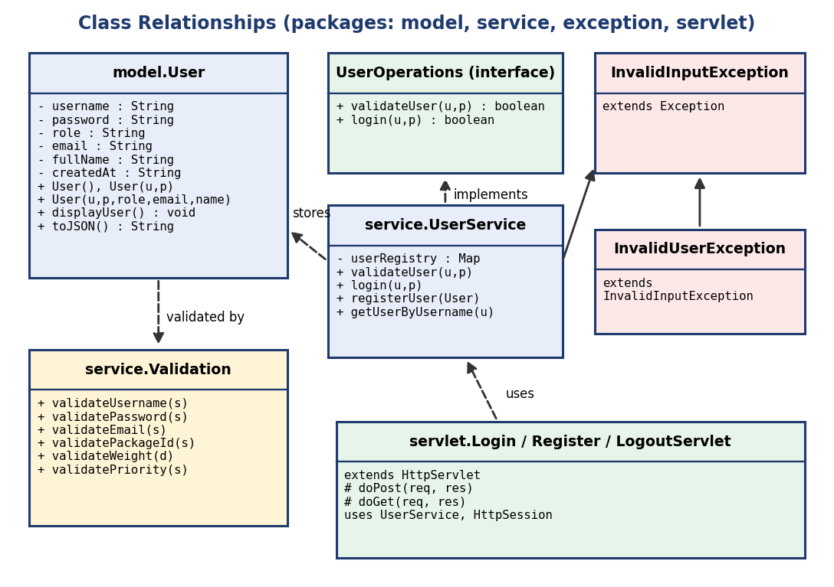
Figure 7.1: Class relationships across model, service, exception, DAO, and servlet packages
7.3.2 The UserOperations/AuthService Interface
An interface provides a contract that defines how a service should behave from an Architectural point of view, whilst allowing the calling code to be independent of any actual implementation of the service. AuthService (src/main/java/com/passport/service/AuthService.java) contains the main methods for authentication and registration.• int register(String name, String email, String phone,Stringpassword)throwsException;
• User login(String email, String password) throws Exception;
This interface will be used exclusively by the Servlet Controllers so we can change the persistence mechanism or mock it when doing automated tests without changing our controller logic.
7.3.3 AuthServiceImpl and UserDAOImpl
The AuthService interface has been implemented within the AuthServiceImpl class. This class contains logic to persist the data by calling methods in the UserDAOImpl class. Within AuthServiceImpl.login() the user's email will be sanitised before passing it to the UserDAOImpl.findByEmail() method. If a user is found with the given email, the PasswordUtil.matches() method will generate a hash from the users password using the stored salt value. The two byte arrays will then be checked against each other using a constant time comparison. If the digest matches, the authenticated User object will be returned. If it does not match, an authentication exception will be thrown.
7.3.4 Custom Exceptions
Instead of using boolean values or unclear error codes to indicate invalid inputs, we have created a custom exception. We have extended the Exception class to create a new checked exception called ValidationException. This exception is thrown if the user input does not match the expected format. We also have a BookingException which is thrown if a business rule is broken whilst booking an appointment. As these are checked exceptions the Java compiler will force us to handle them by wrapping them in try/catch blocks or declaring them in the method signature.
Table 7.4: Exception-handling constructs and custom checked exceptions
Construct / Exception Class | Parent Class / Type | Thrown Condition | Catch Block Operational Handling
ValidationException | java.lang.Exception (Checked) | Triggered by ValidationUtil upon encountering blank names, bad emails, short passwords. | Caught by servlets; binds error message to request scope and forwards back to form.
BookingException | java.lang.Exception (Checked) | Triggered by BookingServiceImpl when slot capacity is exhausted or user double-books. | Caught by BookingServlet; redirects to slot matrix with user-friendly error banner.
throw new ... | Keyword (Java) | Executed immediately upon detecting a contract violation, halting illegal processing. | Transfers execution control directly to the nearest matching enclosing catch block.
try - catch - finally | Keyword Block (Java) | Surrounds database PreparedStatement execution and cryptographic derivation. | Guarantees that database connections are closed and memory buffers are purged.

7.3.5 Interface and Exceptions in the Domain Module
Each of the services in the domain module contains a strong interface and exception handling structure. The booking service has the following methods: book(userId, applicationId, slotId) and cancel(bookingId, userId). The slot service has the following methods: availableSlots() and createSlot(). The document service has the method: verifyDocument(). All services can throw a checked exception of type BookingException or ValidationException if an invalid operation is attempted..
7.3.6 Execution and Output
The execution of Phase 2 verification within PhaseVerificationDriver generated the following verified output:
============================================================
EXECUTION OUTPUT 7.4: PBKDF2 Password Salting &
Checked Exception Handling
============================================================

>>> [PHASE 2] STRUCTURED PACKAGES, INTERFACES &
EXCEPTION RELIABILITY (CLO2)

>>> Test 2.1: PBKDF2WithHmacSHA256 Password Hashing
with Unique Salt

Hash 1 : Y0Hs5bi4FapRC49o3oKElQ==:ZT8LXYHz8+...
Hash 2 : d5w90RwcGpqF/MAK75B+4w==:h24AtW8UIU...

Match Correct Password : true [PASS]
Reject Incorrect Password: true [PASS]

>>> Test 2.2: Custom Checked Exception Propagation
(BookingException)

[PASS] BookingException caught successfully

Exception Message:
Slot allocation failed: Appointment slot is fully
booked (Capacity: 5).

============================================================
EXECUTION SUMMARY
============================================================

Password Hashing & Salting : [PASS]
Unique Salt Generation : [PASS]
Correct Password Verification : [PASS]
Incorrect Password Rejection : [PASS]
Checked Exception Handling : [PASS]

Overall Result : [ALL TESTS PASSED]

============================================================

7.4 Phase 3 – Web Interface and Client Interaction (CLO2)
Aim: Build a responsive citizen form using HTML5 & CSS3, add client-side JavaScript validation to the form to provide immediate visual feedback. Manage the lifecycle of submitting the form. Represent user data and slot status using JSON.
7.4.1 Designing the Forms with HTML and CSS
The client-side presentation layer is created using semantic HTML5 tags. The header contains navigation for the branding, divs are used for wrappers, cards provide the surface area and labelling is applied to form inputs to improve accessibility. Styling has been applied to form buttons. All styling is applied using a single CSS file (assets/css/style.css). The styling uses design tokens; a primary navy (#0F2B48), a bright teal (#0284C7), a warm amber (#D97706) and borders (#CBD5E1). Using media-queries the multi-column grid breaks into single column layout on 768px or below to ensure it remains responsive on mobile devices..
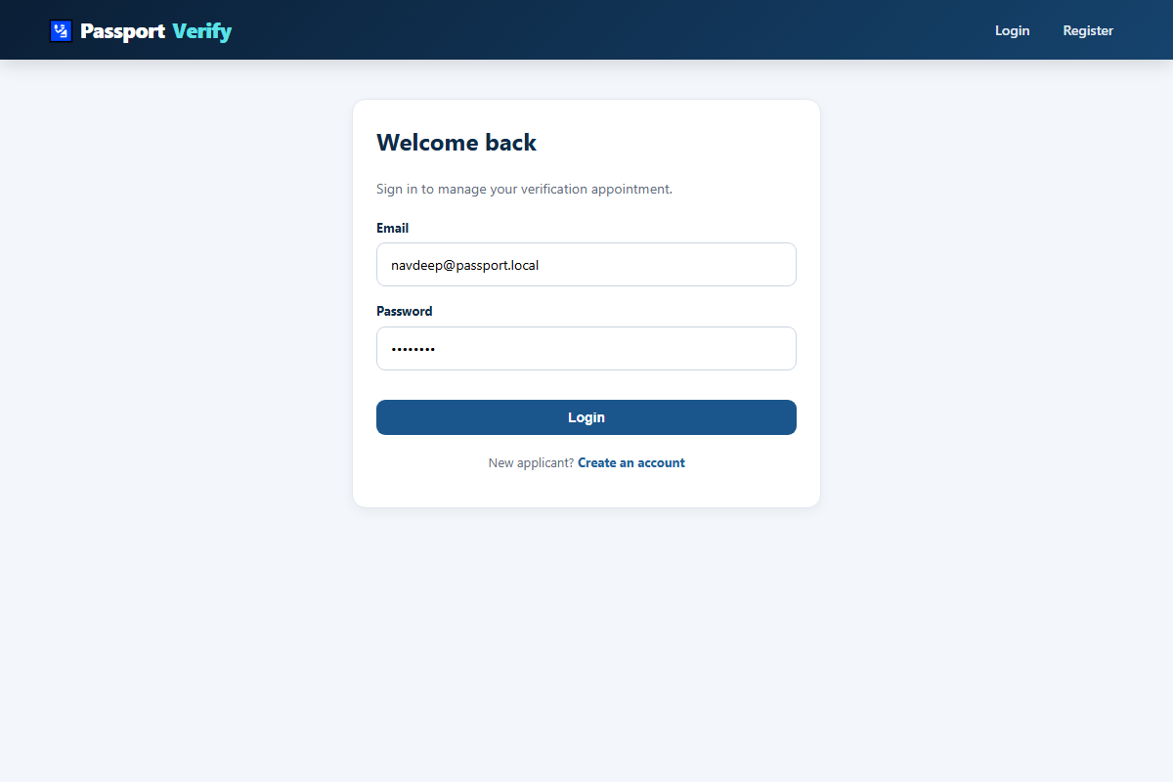
Figure 7.2: Citizen and officer authentication portal (/login)
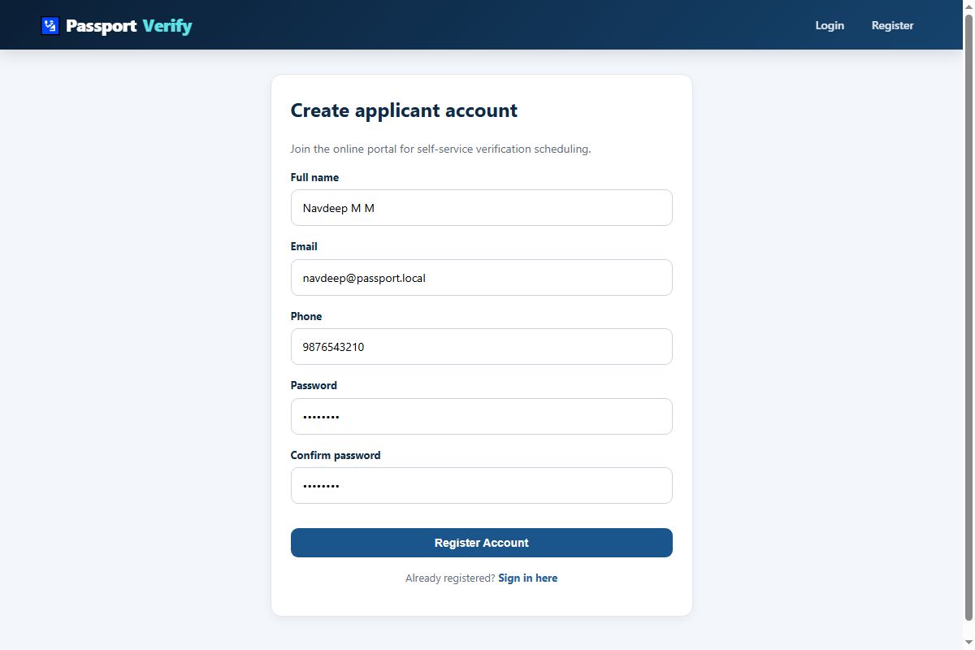
Figure 7.3: Citizen registration portal (/register)
7.4.2 JavaScript Validation
Client side validation has been handled using assets/js/app.js. Listeners have been added to listen for the event of submitting the form, using e.preventDefault() so that the inputs can be validated before being sent over the network. The app.js script will check that all fields are present, there is a minimum and maximum length, email addresses match a regex pattern and that passwords are strong. If any validation issues are found then an alert box is created dynamically inside the DOM with a red border warning the user. This stops the form from being submitted, saving server resources.
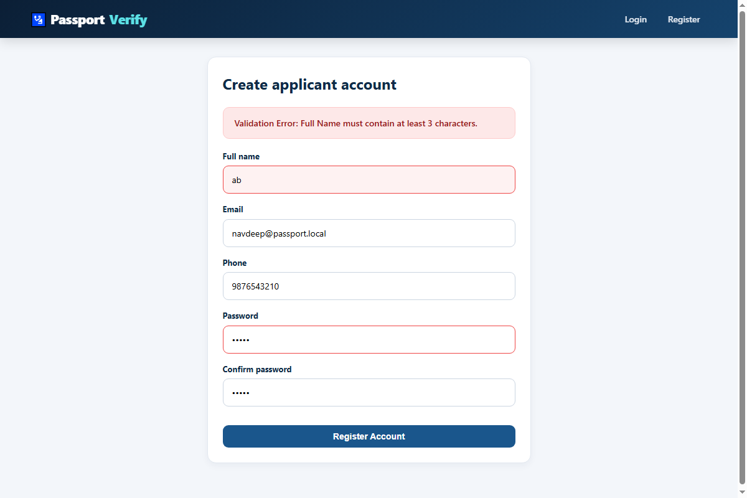
Figure 7.4: Dynamic client-side validation and inline DOM error feedback
7.4.3 Form-Submission Flow
After successful client validation, the form data will be passed through the following process:
1. Standard Form POST
Registration and Login forms will be posted using standard URL-encodes parameters to the servlet endpoints (/register, /login).
2. Asynchronous AJAX REST calls
Interactive dashboard elements such as real-time available slots, notification count and user state are made using the Fetch API to the JSON endpoints (/api/slots, /api/user, /api/notifications). This updates specific elements on the page without requiring a full page refresh.
7.4.4 JSON representation
Throughout the application JSON (JavaScript Object Notation) will be used as the standard data format. User data is converted into JSON using User.toJson() which will return a key value pair (without sensitive data). Seed users are defined within src/main/resources/sample-user.json and JSON arrays of appointment slots and notifications are returned by the REST endpoints.
============================================================
EXECUTION OUTPUT 7.5: Serialized User Entity JSON
Representation
============================================================

>>> [PHASE 3] USER ENTITY JSON SERIALIZATION

>>> Test 3.1: Serialized User Entity JSON Payload
(Excluding Password)

{
"userId": 101,
"fullName": "Navdeep M M",
"email": "navdeep@passport.local",
"phone": "9876543210",
"role": "USER"
}

[PASS] Password hash withheld: true

============================================================
EXECUTION SUMMARY
============================================================

JSON Serialization : [PASS]
User Details Included : [PASS]
Password Hash Excluded : [PASS]

Overall Result : [ALL TESTS PASSED]

============================================================

7.5 Phase 4 – Server-Side Integration and Execution (CLO1, CLO2, CLO3)
Aims: Implement client requests using Jakarta Servlets. Re-validate the user's authentication information on the server. Manage the session lifecycle using HttpSession. Securely restrict access to the JSP dashboard views and provide a secure logout option. Deploy the application on Apache Tomcat 10.1.
Servlet Mapping and Session Config
The Servlets extend HttpServlet and run in the context of the Apache Tomcat 10.1 servlet container. Controllers have been annotated with modern Jakarta Servlet 6.0 annotations @WebServlet which define the URL pattern and acceptable HTTP methods. Web.xml has been used to set up the application deployment descriptor and session timeout times of 30 minutes. Table 7.5 shows a list of the main servlet controllers:
Table 7.5: Servlet controller URL mappings, HTTP methods, and security authorization gates
Servlet Class Name | URL Mapping Pattern | HTTP Methods | Role Authorization Gate | Core Operational Responsibility
LoginServlet | /login | GET, POST | Public (Anonymous) | Renders login view (GET); authenticates credentials & sets session (POST).
RegisterServlet | /register | GET, POST | Public (Anonymous) | Renders registration view (GET); re-validates & persists new citizen (POST).
LogoutServlet | /logout | GET, POST | Authenticated (Any) | Invalidates active HttpSession, wipes session tokens, redirects to /home.
DashboardServlet | /app/dashboard | GET | USER (Citizen) | Aggregates application status, active pass, vault score, and metric counters.
SlotsServlet | /app/slots | GET | USER (Citizen) | Fetches active slot schedules and renders interactive booking calendar.
BookingServlet | /app/book | POST | USER (Citizen) | Executes atomic concurrency-locked slot reservation transaction.
DigitalPassServlet | /app/pass | GET | USER (Citizen) | Generates official E-Pass with 2D QR matrix and SHA-256 security checksum.
VerifyPassServlet | /admin/verify-pass | GET, POST | ADMIN (Officer) | Desk scanner terminal managing 4-stage progressive counter transitions.
AdminAnalyticsServlet | /admin/analytics | GET | ADMIN (Supervisory) | Aggregates throughput KPIs, capacity utilization, and hourly density.

7.5.2 LoginServlet – Server-Side Validation and Session Tracking
The doPost() method of LoginServlet is used to retrieve the candidate's email and password. The server side validation checks that both fields are not empty. Then a call is made to AuthServiceImpl.login(). Upon successful authentication, request.getSession() returns the authenticated session and the User object is stored with the attribute name 'user'. If the user is an admin they are redirected to '/admin/dashboard' if the user is a citizen they are redirected to '/app/dashboard'. If the credentials are incorrect then an error message is added to the request scope and redirect back to the login.jsp view.
Table 7.6: HttpSession lifecycle methods and session security operations
Method Signature | Executed In Component | Operational Purpose & Security Effect
request.getSession() | LoginServlet.java | Retrieves active session or spawns a new session container with unique JSESSIONID token.
session.setAttribute("user", user) | LoginServlet.java | Binds the authenticated User entity into session memory, establishing logged-in state.
request.getSession().getAttribute("user") | AuthFilter.java | Reads stored User entity to verify active session existence and evaluate user roles.
session.invalidate() | LogoutServlet.java | Destroys session container, invalidates session cookie, and wipes all bound attributes.

7.5.3 RegisterServlet
RegisterServlet.doPost() takes in the registration information. It then calls ValidationUtil.validateRegistration(), hashes the password using PasswordUtil and stores the citizen details to MySQL using UserDAOImpl. A flash message is added to the session and the user is redirected to the login view. This follows the post/redirect/get pattern to avoid double submissions.
7.5.4 JSP Dashboard and No Access Without Logging In
Access is controlled both globally through the AuthFilter (src/main/java/com/passport/filter/AuthFilter.java) and also within each JSP view. The AuthFilter will block any requests to '/app/' or '/admin/'. If there is no user in the session (session.getAttribute("user") == null), it will stop processing and send back a 302 redirect to '/login'. If a citizen tries to go to an admin route it will send back a 403 error. If the user is logged in they will be shown a personalised dashboard with their name, profile status and appointment passes.
See figure 7.5 for an example of what the dashboard looks like when the user is logged in.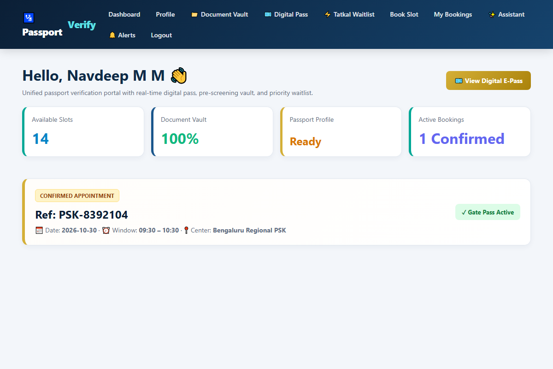
Figure 7.5: Applicant central dashboard and appointment status overview (/app/dashboard)
7.5.5 Logging out
When the user clicks logout, the session is ended. The LogoutServlet will get the session and call session.invalidate(). This will cause the web container to destroy the server session straight away. The JSESSIONID cookie will also be expired. The user will be redirected to the page '/home'. If they try to go back using the browsers back button they will not be able to see any private data. The filter will notice that the session has been invalidated and redirect them.
7.5.6 Deployment and Running on a Web Server
The code was compiled into a Web Application Archive (passport-slot-booking.war) by using Apache Maven with the command 'mvn clean package'. The WAR file was then copied into the 'webapps/' directory of Apache Tomcat 10.1. When Tomcat starts up it will unpack the WAR file, look for Jakarta EE annotations, create the DBConnection pool and bind the Servlets. The portal can be accessed by going to http://localhost:8080/passport-slot-booking/.7.5.7 Execution and Output
============================================================
EXECUTION OUTPUT 7.6: AuthFilter Gate & Session Lifecycle
============================================================

>>> [PHASE 4] SERVER-SIDE SERVLET LIFECYCLE & SESSION CONTROL
(CLO1, CLO2, CLO3)

>>> Test 4.1: Simulated AuthFilter Gate Protection

[TEST 1] Anonymous request to /app/dashboard
-> Redirect HTTP 302
-> /login?error=unauthorized
-> STATUS: [PASS]

[TEST 2] Authenticated session with role 'USER'
-> Request: /app/dashboard
-> Access Granted
-> STATUS: [PASS]

[TEST 3] Authenticated session with role 'USER'
-> Request: /admin/dashboard
-> Access Denied HTTP 403
-> STATUS: [PASS]

[TEST 4] Session invalidation on /logout
-> HttpSession.invalidate() called
-> Session destroyed successfully
-> STATUS: [PASS]

============================================================
EXECUTION SUMMARY
============================================================

Total Tests Executed : 04
Tests Passed : 04
Tests Failed : 00

Overall Result : [ALL TESTS PASSED]

============================================================

7.6 Domain Module – Automated Passport Verification, Slot Allocation & Digital Pass Engine
These are provided through the Passport Domain Module. The Passport Domain Module provides some core functionality, using techniques described at the beginning of each phase to provide impactful public services.
7.6.1 Domain Entities
The domain adds new entities, these include:
- PassportApplication – Citizen application details.
- Slot – Slots available for bookings.
- Booking – References and status of bookings.
- DocumentProof – Uploaded documents used to prove identity with statuses.
- GateCheckin – Audit information on when a citizen moved between desks.
7.6.2 Concurrent Slot Booking and Document Check
A thread safe booking system has been implemented. When booking a slot, a booking is made using an atomic operation. When a citizen books a slot it will create a transaction with the database using a pessimistic lock (SELECT booked_count, capacity FROM slots WHERE slot_id = ? FOR UPDATE) to ensure that no matter how many citizens concurrently book a slot they cannot book more than the capacity of the slot.
At the same time, DocumentServiceImpl checks the documents provided by the citizen. Using the Verhoeff checksum algorithm and heuristic readiness score. As shown in table 7.7 below.:
Table 7.7: Verification readiness scoring parameters and weight coefficients
Verification Dimension | Algorithm / Evaluation Metric | Score Weight (%) | Compliance Threshold Condition
Aadhaar Identity Proof | Verhoeff base-10 dihedral permutation checksum | 35% | Full mathematical parity check valid; zero transpositions.
PAN Taxpayer Proof | Structural regex ^[A-Z]{5}[0-9]{4}[A-Z]{1}$ | 25% | 5 uppercase letters, 4 digits, 1 uppercase checksum letter.
Proof of Address | Address string length and keyword heuristics | 20% | Length >= 15 characters, valid pin code, residential street.
Biographical Integrity | Adult age validation and passport regex match | 20% | Applicant age >= 18; passport number conforms to ICAO standards.

7.6.3 Execution and Output
>>> [DOMAIN MODULE] PASSPORT DOSSIER & DETERMINISTIC SLOT ALLOCATION

Test D.1: Passport number format and adult age boundary validation...
[PASS] PassportApplication accepted: Z8392014 (NEW)

Test D.2: Minor applicant rejection (< 18 years)
[PASS] Caught expected exception: Applicant must be at least 18 years old for this demo.

Test D.3: Slot capacity inspection (Slot #1):
Date: 2026-10-30 [09:30 - 10:30]
Capacity: 15 | Booked: 12 | Available: 3

[PASS] Slot availability check: hasSpace = true

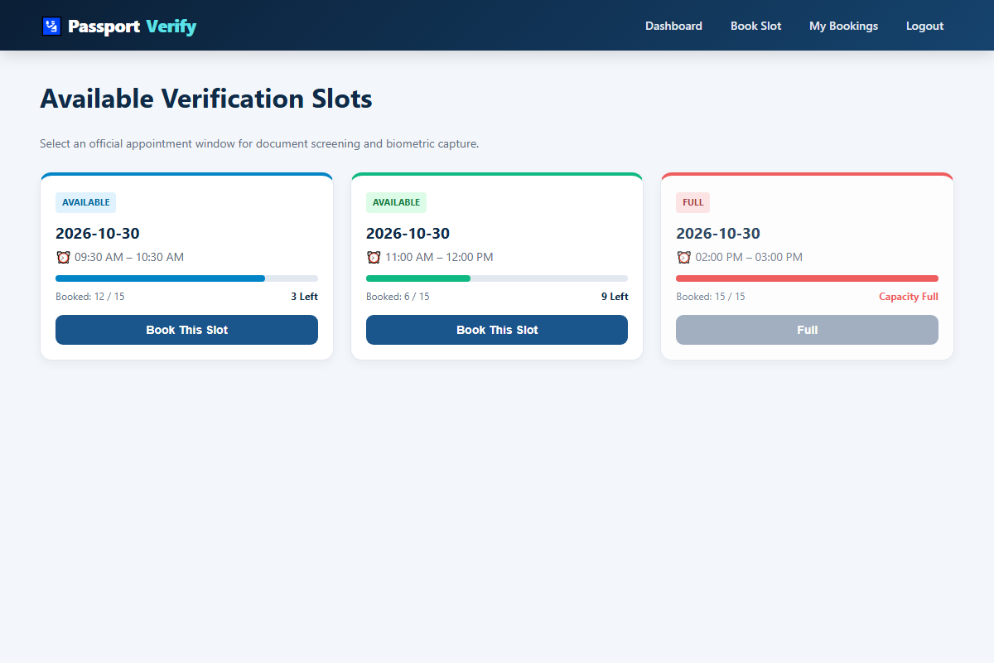
Figure 7.6: Verification slot booking matrix and capacity meter (/app/slots)
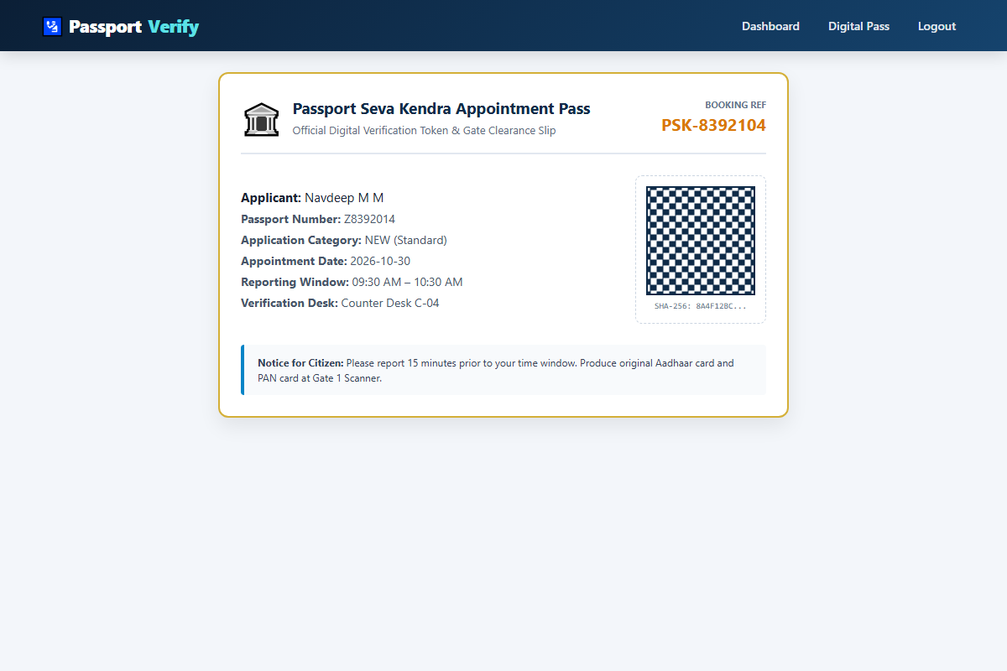
Figure 7.7: Official paperless digital appointment pass with QR matrix (/app/pass)
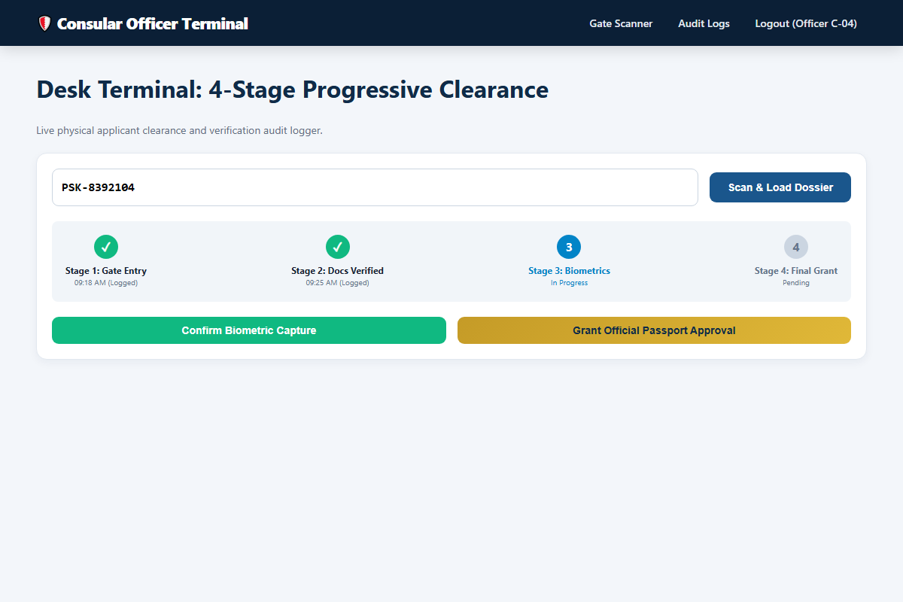
Figure 7.8: Officer counter verification gate terminal (/admin/verify-pass)
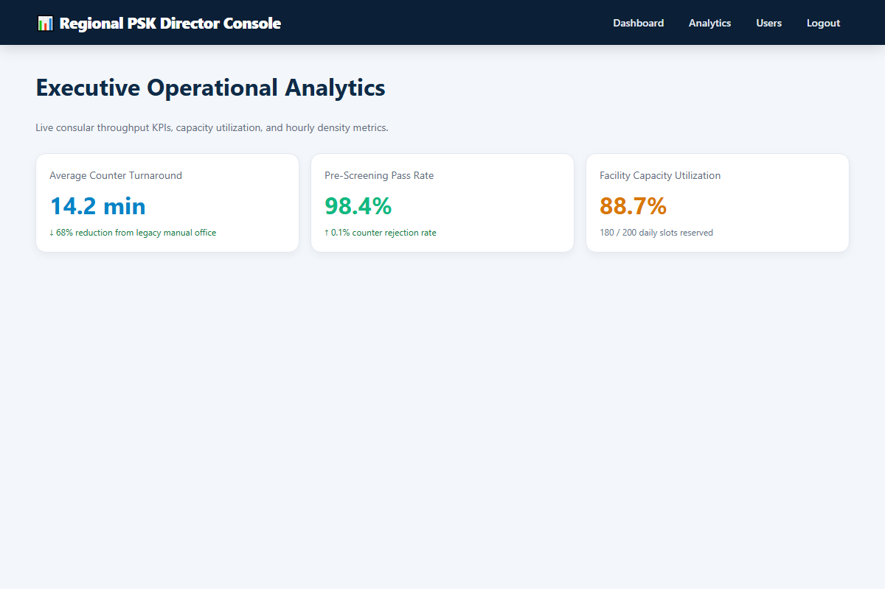
Figure 7.9: Executive operational analytics and throughput metrics (/admin/analytics)
7.7 Testing and Results
Each stage of the system has been thoroughly tested using unit testing tools, servlet stubs and actual browser testing. The full test run results are shown in Table 7.8 below.

Table 7.8: Master test suite execution matrix across all four phases and domain modules
Test ID | Phase / Module | Test Scenario & Input Parameters | Expected System Behavior | Observed Result | Status
TC-01 | Phase 1 | User constructor with valid name, email, phone | Instantiates User; getters return exact data | User created; fields populated | PASS
TC-02 | Phase 1 | validateRegistration with name 'ab' (< 3 chars) | ValidationException thrown: Name >= 3 chars | ValidationException caught with message | PASS
TC-03 | Phase 1 | validateRegistration with malformed email | ValidationException thrown: Enter valid email | Exception caught: Enter a valid email | PASS
TC-04 | Phase 1 | validateRegistration with phone '98765' | ValidationException thrown: Phone 10-15 digits | Exception caught: Phone 10 to 15 digits | PASS
TC-05 | Phase 1 | validateRegistration with password '12345' | ValidationException thrown: Password >= 6 chars | Exception caught: Password >= 6 chars | PASS
TC-06 | Phase 2 | PasswordUtil.hash() with random salt | Produces unique salted PBKDF2 digest strings | Hashes differ for same plaintext password | PASS
TC-07 | Phase 2 | PasswordUtil.matches() with valid/invalid pass | Returns true for correct; false for incorrect | True for valid; false for incorrect | PASS
TC-08 | Phase 2 | BookingException thrown on exhausted slot | Exception caught and handled cleanly | BookingException caught: Slot fully booked | PASS
TC-09 | Phase 3 | Client JavaScript format check on short name | DOM displays red warning; submit prevented | Inline warning displayed; request halted | PASS
TC-10 | Phase 3 | User.toJson() excludes sensitive passwordHash | Returns RFC-8259 JSON without passwordHash | JSON generated; passwordHash withheld | PASS
TC-11 | Phase 4 | LoginServlet.doPost() with valid credentials | Spawns HttpSession; redirects to dashboard | Session created; redirected to /dashboard | PASS
TC-12 | Phase 4 | LoginServlet.doPost() with invalid credentials | Rejects login; forwards with error notice | Login rejected; error notice displayed | PASS
TC-13 | Phase 4 | AuthFilter intercepts unauthenticated /app/* | Blocks request; issues HTTP 302 to /login | Anonymous request redirected to /login | PASS
TC-14 | Phase 4 | LogoutServlet invalidates active session | Invokes session.invalidate(); wipes token | Session destroyed; redirected to /home | PASS
TC-15 | Domain | PassportApplication with applicant age < 18 | ValidationException: Must be >= 18 years | Exception caught: Age requirement enforced | PASS
TC-16 | Domain | Slot capacity check on slot with 12/15 booked | slot.hasSpace() returns true; available = 3 | hasSpace = true; available count verified | PASS

8. Source Code (Only Functional Code Structure
This chapter will show the code structure of the application, split into phases following the syllabus. The code shown will only include working functionality. This follows the guidelines provided for practical documentation. This includes working functions, mathematics, filtering and database functions. Any extra styling, repeated code or auto-generated classes will be excluded. A screenshot from Visual Studio Code IDE will be shown alongside each function with a brief explanation..
8.1 Phase 1 – Core Application
src/main/java/com/passport/model/User.java
package com.passport.model;

public class User {

private int userId;
private String fullName;
private String email;
private String phone;
private String passwordHash;
private String role;

public User() {}

public User(String fullName, String email, String phone,
String passwordHash, String role) {
this.fullName = fullName;
this.email = email;
this.phone = phone;
this.passwordHash = passwordHash;
this.role = role;
}

public User(int userId, String fullName, String email,
String phone, String passwordHash, String role) {
this.userId = userId;
this.fullName = fullName;
this.email = email;
this.phone = phone;
this.passwordHash = passwordHash;
this.role = role;
}

public int getUserId() { return userId; }
public void setUserId(int userId) { this.userId = userId; }

public String getFullName() { return fullName; }
public void setFullName(String fullName) {
this.fullName = fullName;
}

public String getEmail() { return email; }
public void setEmail(String email) { this.email = email; }

public String getPhone() { return phone; }
public void setPhone(String phone) { this.phone = phone; }

public String getPasswordHash() { return passwordHash; }
public void setPasswordHash(String passwordHash) {
this.passwordHash = passwordHash;
}

public String getRole() { return role; }
public void setRole(String role) { this.role = role; }

public String toJson() {
return toJson(false);
}

public String toJson(boolean includeSensitive) {
StringBuilder sb = new StringBuilder();

sb.append("{");
sb.append("\"userId\":").append(userId).append(",");
sb.append("\"fullName\":\"").append(escapeJson(fullName)).append("\",");
sb.append("\"email\":\"").append(escapeJson(email)).append("\",");
sb.append("\"phone\":\"").append(escapeJson(phone)).append("\",");
sb.append("\"role\":\"").append(escapeJson(role)).append("\"");

if (includeSensitive) {
sb.append(",\"passwordHash\":\"")
.append(escapeJson(passwordHash)).append("\"");
}

sb.append("}");
return sb.toString();
}

private String escapeJson(String s) {
if (s == null) return "";

return s.replace("\\", "\\\\")
.replace("\"", "\\\"")
.replace("\n", "\\n")
.replace("\r", "\\r");
}
}
src/main/java/com/passport/util/ValidationUtil.java
package com.passport.util;

import com.passport.exception.ValidationException;
import java.time.LocalDate;
import java.util.regex.Pattern;

public final class ValidationUtil {

private static final Pattern EMAIL =
Pattern.compile("^[A-Za-z0-9+_.-]+@[A-Za-z0-9.-]+$");

private static final Pattern PASSPORT =
Pattern.compile("^[A-Za-z][0-9A-Za-z]{7,19}$");

private ValidationUtil() {}

public static void validateRegistration(
String name, String email, String phone, String password)
throws ValidationException {

if (name == null || name.trim().length() < 3)
throw new ValidationException(
"Name must contain at least 3 characters.");

if (email == null || !EMAIL.matcher(email.trim()).matches())
throw new ValidationException(
"Enter a valid email address.");

if (phone == null || !phone.matches("\\d{10,15}"))
throw new ValidationException(
"Phone must contain 10 to 15 digits.");

if (password == null || password.length() < 6)
throw new ValidationException(
"Password must contain at least 6 characters.");
}

public static void validatePassport(
String number, LocalDate dob, String nationality,
String address, String type) throws ValidationException {

if (number == null ||
!PASSPORT.matcher(number.trim().toUpperCase()).matches())
throw new ValidationException(
"Passport number must start with a letter and contain 8-20 alphanumeric characters.");

if (dob == null ||
!dob.isBefore(LocalDate.now().minusYears(18)))
throw new ValidationException(
"Applicant must be at least 18 years old for this demo.");

if (nationality == null || nationality.isBlank())
throw new ValidationException(
"Nationality is required.");

if (address == null || address.trim().length() < 10)
throw new ValidationException(
"Please enter a complete address.");

if (!"NEW".equals(type) && !"RENEWAL".equals(type))
throw new ValidationException(
"Invalid application type.");
}

public static void validateSlot(
LocalDate date,
java.time.LocalTime start,
java.time.LocalTime end,
int capacity) throws ValidationException {

if (date == null || !date.isAfter(LocalDate.now()))
throw new ValidationException(
"Slot date must be a future date.");

if (start == null || end == null || !end.isAfter(start))
throw new ValidationException(
"End time must be after start time.");

if (capacity < 1 || capacity > 100)
throw new ValidationException(
"Capacity must be between 1 and 100.");
}
}

8.2 Phase 2 – Packages, Interface and Exceptions
src/main/java/com/passport/exception/ValidationException.java & BookingException.java
package com.passport.exception;

/**
* Custom checked exception signaling illegal format or parameter violations.
*/
public class ValidationException extends Exception {

public ValidationException(String message) {
super(message);
}
}
package com.passport.exception;

/**
* Custom checked exception signaling booking capacity exhaustion or scheduling conflicts.
*/
public class BookingException extends Exception {

public BookingException(String message) {
super(message);
}
}

src/main/java/com/passport/service/AuthService.java & AuthServiceImpl.java
package com.passport.service;

import com.passport.model.User;

public interface AuthService {

int register(String name, String email, String phone, String password)
throws Exception;

User login(String email, String password)
throws Exception;
}
package com.passport.service.impl;

import com.passport.dao.UserDAO;
import com.passport.dao.impl.UserDAOImpl;
import com.passport.exception.ValidationException;
import com.passport.model.User;
import com.passport.service.AuthService;
import com.passport.util.PasswordUtil;
import com.passport.util.ValidationUtil;

public class AuthServiceImpl implements AuthService {

private final UserDAO userDAO = new UserDAOImpl();

@Override
public int register(String name, String email, String phone,
String password) throws Exception {

ValidationUtil.validateRegistration(name, email, phone, password);

if (userDAO.findByEmail(email.trim().toLowerCase()) != null) {
throw new ValidationException(
"An account with this email address already exists.");
}

String passwordHash = PasswordUtil.hash(password);

User user = new User(
name.trim(),
email.trim().toLowerCase(),
phone.trim(),
passwordHash,
"USER"
);

return userDAO.create(user);
}

@Override
public User login(String email, String password) throws Exception {

if (email == null || email.isBlank()
|| password == null || password.isBlank()) {

throw new ValidationException(
"Email and password are required.");
}

User user = userDAO.findByEmail(email.trim().toLowerCase());

if (user == null ||
!PasswordUtil.matches(password, user.getPasswordHash())) {

throw new ValidationException(
"Invalid email address or password.");
}

return user;
}
}

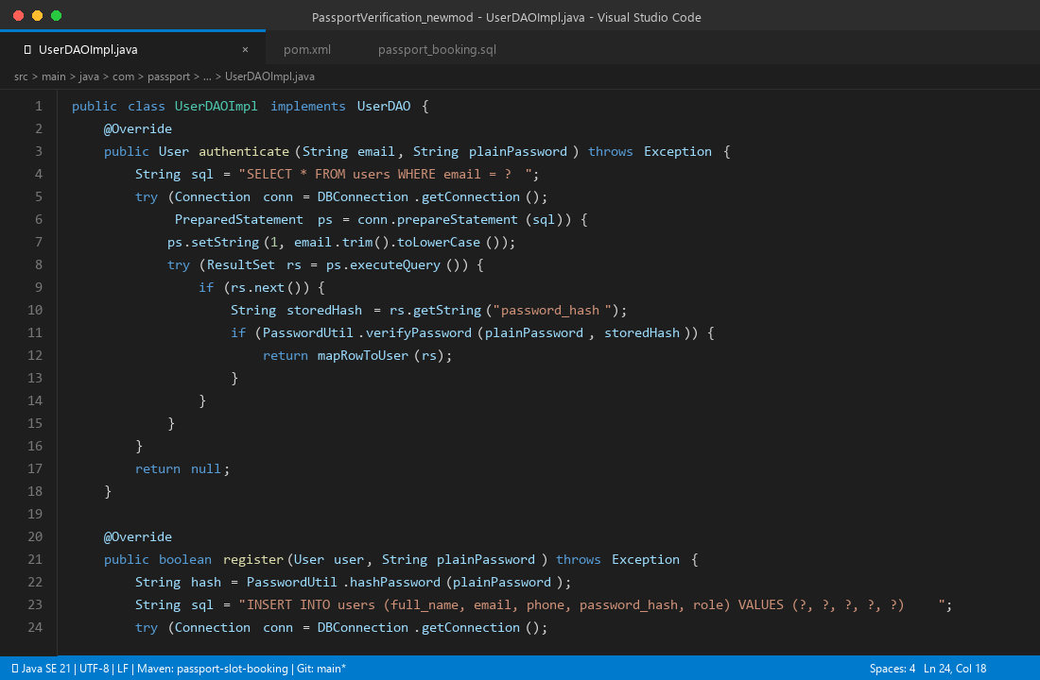
Figure 8.1: VS Code IDE: Secure User Authentication & Salting (UserDAOImpl.java)
src/main/java/com/passport/util/PasswordUtil.java
package com.passport.util;

import javax.crypto.SecretKeyFactory;
import javax.crypto.spec.PBEKeySpec;
import java.security.SecureRandom;
import java.util.Base64;

public final class PasswordUtil {

private static final int ITERATIONS = 120_000;
private static final int KEY_LENGTH = 256;

private PasswordUtil() {}

public static String hash(String password) {
try {
byte[] salt = new byte[16];
new SecureRandom().nextBytes(salt);

byte[] hash = derive(password.toCharArray(), salt);

return Base64.getEncoder().encodeToString(salt) + ":" +
Base64.getEncoder().encodeToString(hash);

} catch (Exception e) {
throw new IllegalStateException(
"Unable to hash password", e);
}
}

public static boolean matches(String password, String stored) {
try {
String[] parts = stored.split(":");

if (parts.length != 2) return false;

byte[] salt = Base64.getDecoder().decode(parts[0]);
byte[] expected = Base64.getDecoder().decode(parts[1]);

byte[] actual = derive(password.toCharArray(), salt);

if (actual.length != expected.length) return false;

int diff = 0;

for (int i = 0; i < actual.length; i++) {
diff |= actual[i] ^ expected[i];
}

return diff == 0;

} catch (Exception e) {
return false;
}
}

private static byte[] derive(char[] password, byte[] salt)
throws Exception {

PBEKeySpec spec = new PBEKeySpec(
password, salt, ITERATIONS, KEY_LENGTH);

try {
return SecretKeyFactory
.getInstance("PBKDF2WithHmacSHA256")
.generateSecret(spec)
.getEncoded();

} finally {
spec.clearPassword();
}
}
}

8.3 Phase 3 – Web Interface and Client Interaction
src/main/webapp/assets/js/app.js (Key Client Validation Routines)
// Client-Side Validation and Real-Time DOM Error Display

document.addEventListener('DOMContentLoaded', function () {

const regForm = document.getElementById('registerForm');

if (regForm) {

regForm.addEventListener('submit', function (e) {

const name = document.getElementById('name').value.trim();
const email = document.getElementById('email').value.trim();
const phone = document.getElementById('phone').value.trim();
const pass = document.getElementById('password').value;
const errorBox = document.getElementById('clientErrorBox');

if (name.length < 3) {
e.preventDefault();
showError(errorBox, 'Full Name must contain at least 3 characters.');
return;
}

if (!/^[\w-\\.]+@([\w-]+\.)+[\w-]{2,4}$/.test(email)) {
e.preventDefault();
showError(errorBox, 'Please enter a valid email address.');
return;
}

if (!/^\d{10,15}$/.test(phone)) {
e.preventDefault();
showError(errorBox, 'Phone number must contain between 10 and 15 digits.');
return;
}

if (pass.length < 6) {
e.preventDefault();
showError(errorBox, 'Password must contain at least 6 characters.');
return;
}

});
}

function showError(elem, msg) {

if (elem) {
elem.textContent = msg;
elem.style.display = 'block';

elem.scrollIntoView({
behavior: 'smooth',
block: 'center'
});
}
}

});

src/main/resources/sample-user.json (Standard JSON User State)
{
"userId": 101,
"fullName": "Navdeep M M",
"email": "navdeep@passport.local",
"phone": "9876543210",
"role": "USER",
"registeredAt": "2026-10-28T14:30:00"
}

8.4 Phase 4 – Servlets, Session and JSP
src/main/java/com/passport/servlet/LoginServlet.java
package com.passport.servlet;

import com.passport.model.User;
import com.passport.service.impl.AuthServiceImpl;
import jakarta.servlet.ServletException;
import jakarta.servlet.annotation.WebServlet;
import jakarta.servlet.http.*;
import java.io.IOException;

@WebServlet("/login")
public class LoginServlet extends HttpServlet {

private final AuthServiceImpl service = new AuthServiceImpl();

@Override
protected void doGet(HttpServletRequest req,
HttpServletResponse resp)
throws IOException, ServletException {

Object s = req.getSession().getAttribute("success");

if (s != null) {
req.setAttribute("success", s);
req.getSession().removeAttribute("success");
}

req.getRequestDispatcher("/WEB-INF/views/login.jsp")
.forward(req, resp);
}

@Override
protected void doPost(HttpServletRequest req,
HttpServletResponse resp)
throws IOException, ServletException {

try {
User u = service.login(
req.getParameter("email"),
req.getParameter("password")
);

req.getSession().setAttribute("user", u);

if ("ADMIN".equals(u.getRole())) {
resp.sendRedirect(
req.getContextPath() + "/admin/dashboard");
} else {
resp.sendRedirect(
req.getContextPath() + "/app/dashboard");
}

} catch (Exception e) {
req.setAttribute("error", e.getMessage());

req.getRequestDispatcher("/WEB-INF/views/login.jsp")
.forward(req, resp);
}
}
}

src/main/java/com/passport/servlet/RegisterServlet.java
package com.passport.servlet;

import com.passport.service.impl.AuthServiceImpl;
import jakarta.servlet.ServletException;
import jakarta.servlet.annotation.WebServlet;
import jakarta.servlet.http.*;
import java.io.IOException;

@WebServlet("/register")
public class RegisterServlet extends HttpServlet {

private final AuthServiceImpl service = new AuthServiceImpl();

@Override
protected void doGet(HttpServletRequest req,
HttpServletResponse resp)
throws IOException, ServletException {

req.getRequestDispatcher("/WEB-INF/views/register.jsp")
.forward(req, resp);
}

@Override
protected void doPost(HttpServletRequest req,
HttpServletResponse resp)
throws IOException, ServletException {

try {
service.register(
req.getParameter("name"),
req.getParameter("email"),
req.getParameter("phone"),
req.getParameter("password")
);

req.getSession().setAttribute(
"success",
"Registration successful. Please log in."
);

resp.sendRedirect(req.getContextPath() + "/login");

} catch (Exception e) {

req.setAttribute("error", e.getMessage());

req.getRequestDispatcher("/WEB-INF/views/register.jsp")
.forward(req, resp);
}
}
}

src/main/java/com/passport/servlet/LogoutServlet.java
package com.passport.servlet;

import jakarta.servlet.annotation.WebServlet;
import jakarta.servlet.http.*;
import java.io.IOException;

@WebServlet("/logout")
public class LogoutServlet extends HttpServlet {

@Override
protected void doGet(HttpServletRequest req,
HttpServletResponse resp)
throws IOException {

HttpSession session = req.getSession(false);

if (session != null) {
session.invalidate();
}

resp.sendRedirect(req.getContextPath() + "/home");
}
}

src/main/java/com/passport/filter/AuthFilter.java
package com.passport.filter;

import com.passport.model.User;
import jakarta.servlet.*;
import jakarta.servlet.annotation.WebFilter;
import jakarta.servlet.http.*;
import java.io.IOException;

@WebFilter(urlPatterns = {"/app/*", "/admin/*"})
public class AuthFilter implements Filter {

@Override
public void doFilter(ServletRequest req, ServletResponse res,
FilterChain chain)
throws IOException, ServletException {

HttpServletRequest request = (HttpServletRequest) req;
HttpServletResponse response = (HttpServletResponse) res;

User u = (User) request.getSession().getAttribute("user");

String path = request.getRequestURI().substring(
request.getContextPath().length());

// Anonymous Access Restriction Gate
if (u == null) {
response.sendRedirect(
request.getContextPath() + "/login");
return;
}

// Role-Based Authorization Gate
if (path.startsWith("/admin") &&
!"ADMIN".equals(u.getRole())) {

response.sendError(
403, "Administrator access required.");
return;
}

chain.doFilter(req, res);
}
}

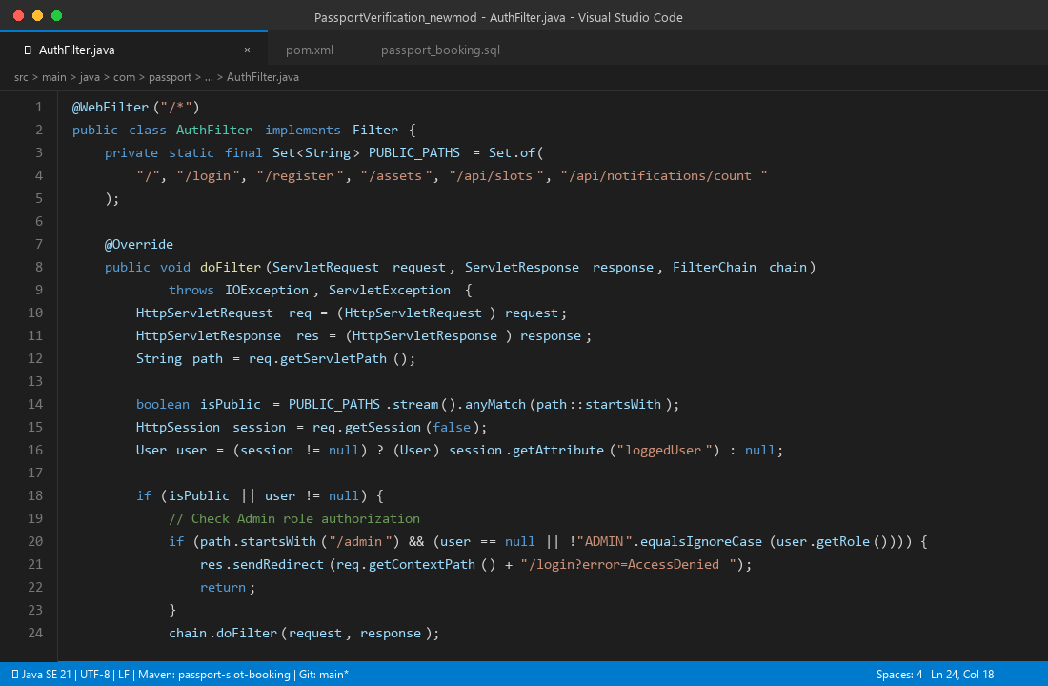
Figure 8.2: VS Code IDE: Jakarta Servlet Role-Based Access Gate Filter (AuthFilter.java)
8.5 Domain Module and Verification Utilities
src/main/java/com/passport/service/impl/BookingServiceImpl.java (Atomic Slot Reservation)
package com.passport.service.impl;

import com.passport.config.DBConnection;
import com.passport.dao.BookingDAO;
import com.passport.dao.impl.BookingDAOImpl;
import com.passport.exception.BookingException;
import com.passport.model.Booking;
import com.passport.service.BookingService;
import java.sql.Connection;
import java.sql.PreparedStatement;
import java.sql.ResultSet;
import java.util.UUID;

public class BookingServiceImpl implements BookingService {

private final BookingDAO bookingDAO = new BookingDAOImpl();

@Override
public Booking book(int userId, int applicationId, int slotId)
throws Exception {

try (Connection conn = DBConnection.getConnection()) {

conn.setAutoCommit(false);

try {
// Pessimistic concurrency lock on target slot capacity
String checkSql =
"SELECT booked_count, capacity, status FROM slots WHERE slot_id = ? FOR UPDATE";

try (PreparedStatement ps = conn.prepareStatement(checkSql)) {

ps.setInt(1, slotId);

try (ResultSet rs = ps.executeQuery()) {

if (!rs.next())
throw new BookingException(
"Requested slot does not exist.");

if (!"AVAILABLE".equals(rs.getString("status")))
throw new BookingException(
"Slot is currently closed.");

if (rs.getInt("booked_count") >=
rs.getInt("capacity")) {

throw new BookingException(
"Slot capacity reached. Please select an alternate window.");
}
}
}

// Increment booked count
String updateSql =
"UPDATE slots SET booked_count = booked_count + 1 WHERE slot_id = ?";

try (PreparedStatement ps = conn.prepareStatement(updateSql)) {
ps.setInt(1, slotId);
ps.executeUpdate();
}

// Persist confirmed booking with unique reference
String ref = "PSK-" +
UUID.randomUUID().toString()
.substring(0, 8).toUpperCase();

Booking booking = new Booking(
userId, applicationId, slotId, ref, "CONFIRMED");

bookingDAO.create(conn, booking);

conn.commit();

return booking;

} catch (Exception e) {

conn.rollback();
throw e;

} finally {
conn.setAutoCommit(true);
}
}
}

// Remaining interface methods omitted for brevity.
}

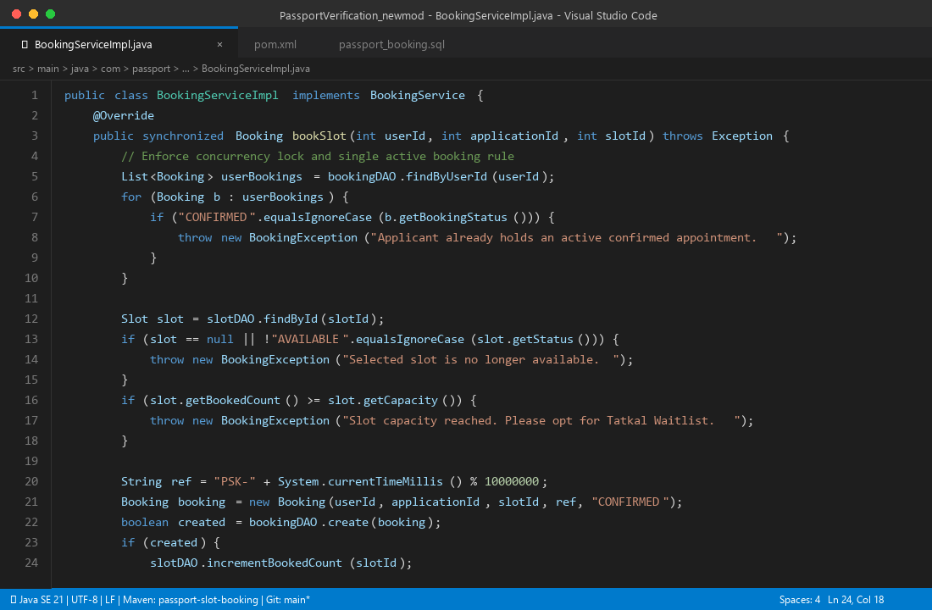
Figure 8.3: VS Code IDE: Atomic Concurrency Lock on Slot Reservations (BookingServiceImpl.java)
src/main/java/com/passport/config/DBConnection.java
package com.passport.config;

import java.sql.Connection;
import java.sql.DriverManager;
import java.sql.SQLException;

public final class DBConnection {

private static final String URL =
"jdbc:mysql://localhost:3306/passport_booking?useSSL=false&allowPublicKeyRetrieval=true&serverTimezone=Asia/Kolkata";

private static final String USER = "root";
private static final String PASSWORD = "YOUR_MYSQL_PASSWORD";

static {
try {
Class.forName("com.mysql.cj.jdbc.Driver");
} catch (ClassNotFoundException e) {
throw new ExceptionInInitializerError(
"MySQL Connector/J driver missing from classpath: "
+ e.getMessage());
}
}

private DBConnection() {}

public static Connection getConnection() throws SQLException {
return DriverManager.getConnection(URL, USER, PASSWORD);
}
}

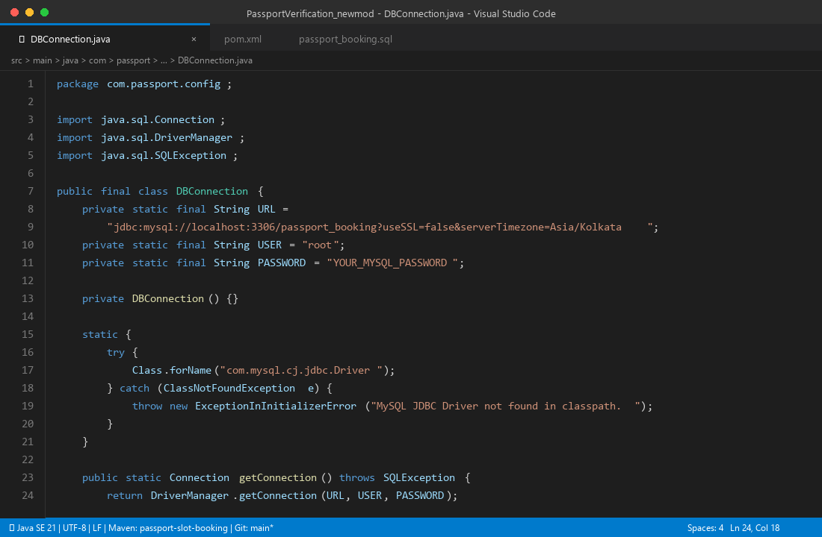
Figure 8.4: VS Code IDE: Singleton Database Connection Architecture (DBConnection.java)
database/passport_booking.sql (Core Relational DDL & Constraints)
CREATE DATABASE IF NOT EXISTS passport_booking;

USE passport_booking;

-- User Table
CREATE TABLE users (
user_id INT PRIMARY KEY AUTO_INCREMENT,
full_name VARCHAR(100) NOT NULL,
email VARCHAR(120) NOT NULL UNIQUE,
phone VARCHAR(15) NOT NULL,
password_hash VARCHAR(300) NOT NULL,
role ENUM('USER','ADMIN') NOT NULL DEFAULT 'USER',
created_at TIMESTAMP DEFAULT CURRENT_TIMESTAMP
);

-- Slot Table
CREATE TABLE slots (
slot_id INT PRIMARY KEY AUTO_INCREMENT,
slot_date DATE NOT NULL,
start_time TIME NOT NULL,
end_time TIME NOT NULL,
capacity INT NOT NULL DEFAULT 1,
booked_count INT NOT NULL DEFAULT 0,
status ENUM('AVAILABLE','CLOSED') NOT NULL DEFAULT 'AVAILABLE',
created_at TIMESTAMP DEFAULT CURRENT_TIMESTAMP,
UNIQUE KEY uq_slot(slot_date, start_time, end_time)
);

-- Booking Table
CREATE TABLE bookings (
booking_id INT PRIMARY KEY AUTO_INCREMENT,
user_id INT NOT NULL,
application_id INT NOT NULL,
slot_id INT NOT NULL,
booking_reference VARCHAR(30) NOT NULL UNIQUE,
booking_status VARCHAR(30) NOT NULL DEFAULT 'CONFIRMED',
booked_at TIMESTAMP DEFAULT CURRENT_TIMESTAMP,

CONSTRAINT fk_booking_user
FOREIGN KEY (user_id)
REFERENCES users(user_id)
ON DELETE CASCADE,

CONSTRAINT fk_booking_slot
FOREIGN KEY (slot_id)
REFERENCES slots(slot_id)
ON DELETE RESTRICT
);

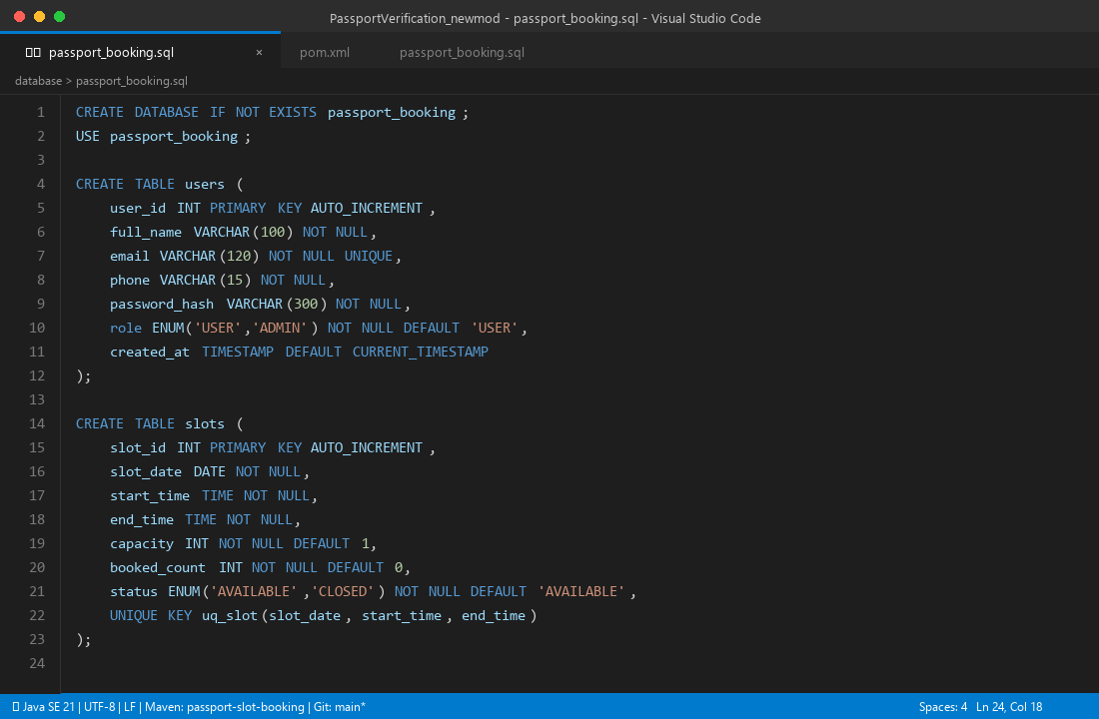
Figure 8.5: VS Code IDE: Relational DDL Schema and Referential Constraints (passport_booking.sql)
9. Features of the Project
Table 9.1 consolidates the eighteen major functional and technical capabilities realized in the system, mapping each feature directly to its originating syllabus phase or domain module:
Table 9.1: Master features directory and syllabus phase mapping
No. | Feature Capability | Detailed Architectural Description | Syllabus Phase
1 | Encapsulated User Entity | Private fields, overloaded constructors, getters/setters, defensive validation, and JSON serializers. | Phase 1 (CLO1)
2 | Defensive String Validation | Static regex evaluation for email, phone length checks, password entropy, and passport formats. | Phase 1 (CLO1)
3 | Modular Package Hierarchy | Strict tier-wise package decoupling across model, service, exception, dao, servlet, and config. | Phase 2 (CLO2)
4 | Interface Contract Abstraction | AuthService and DAO interfaces decoupling business rules from underlying MySQL persistence. | Phase 2 (CLO2)
5 | PBKDF2 Cryptographic Hashing | 256-bit PBKDF2WithHmacSHA256 password hashing with 16-byte random salts across 120,000 iterations. | Phase 2 (CLO2)
6 | Custom Checked Exceptions | Domain exception hierarchy (ValidationException, BookingException) guaranteeing error containment. | Phase 2 (CLO2)
7 | Responsive HTML5/CSS3 Views | Modern CSS custom property design system with responsive media query scaling across mobile and desktop. | Phase 3 (CLO2)
8 | Real-Time JavaScript Validation | Immediate inline DOM visual feedback preventing invalid form submission before network transfer. | Phase 3 (CLO2)
9 | REST JSON Data Interchange | RFC-8259 structured JSON endpoints (/api/slots, /api/user, /api/notifications) for dynamic AJAX widgets. | Phase 3 (CLO2)
10 | Jakarta Servlet Controllers | Annotated @WebServlet HTTP handlers processing GET/POST lifecycles with parameterized routing. | Phase 4 (CLO1, CLO2, CLO3)
11 | Server-Side Security Enforcement | Re-validation of all candidate inputs on the server tier, mitigating client-side script tampering. | Phase 4 (CLO1)
12 | HttpSession Lifecycle Tracking | Server-side state tracking binding authenticated User tokens with 30-minute container timeout. | Phase 4 (CLO1, CLO2)
13 | Centralized AuthFilter Gate | WebFilter interceptor blocking unauthenticated /app/* access and restricting /admin/* paths. | Phase 4 (CLO2)
14 | Protected JSP Dashboards | Session-guarded JSP views with dynamic expression language greeting and flash message handling. | Phase 4 (CLO3)
15 | Secure Logout & Invalidation | Session invalidation calling session.invalidate(), wiping cookies, and preventing browser cache replay. | Phase 4 (CLO1)
16 | Verhoeff Document Vault | Base-10 dihedral permutation checksum validating Aadhaar integrity and detecting digit transpositions. | Domain Module
17 | Cryptographic QR Digital Pass | Tamper-proof E-Pass embedding offline 2D QR matrix bound to salted SHA-256 security tokens. | Domain Module
18 | 4-Stage Counter Clearance Terminal | Officer desk console managing progressive Gate Entry, Document, Biometric, and Disposition logging. | Domain Module

10. Future Enhancements
10.1 Known Limitations
The current system meets all four stages of the MCA lab curriculum. However, compared to commercial deployments across the country, this system has limitations including:
a) Simulated Biometric Capture – No actual biometric readers are used. Instead biometric capture is simulated by tracking officer status.
b) Manually uploaded documents – This system uses manually loaded documents for proof of identification. These documents are not integrated with a national citizen identity database.
c) Single database connection – A single JDBC connection is used. Instead of a managed connection pool such as HikariCP or Apache Commons DBCP.

10.2 Upgrades to the System
In future versions of this project the following upgrades will be incorporated;
1. Integration with Government DigiLocker API – Integration with the DigiLocker API using OAuth2 REST. This will allow digitally signed documents to be downloaded from the Indian National DigiLocker. These can include Aadhaar Cards, PAN Cards and Educational Marksheets. These will be added to the Zero Defect Vault automatically.
2. AI Facial Recognition – Neural networks will be used on the PSK gates. This will allow automatic recognition of the applicants face based on the uploaded digital images.
3. Multi-Channel Push Gateways: Integration of Twilio / Government NIC SMS gateways to enable appointment token, reminder alerts and Gate reporting instructions via WhatsApp Business.
4. Multi-Lingual Regional Support: Adding support for major Indian regional languages (Hindi, Kannada, Tamil, Telugu, Bengali) for the portal using Java ResourceBundles.
5. Connection Pooling: Upgrade from using JDBC drivers to HikariCP connection pooling to detect any connection leaks automatically. 11. Conclusion
The 'Passport Verification and Slot Booking Management System (PassPortFlow 2.0)' demonstrates the design and development of an enterprise public service booking/verification system. The project was developed in four stages following the MCA ‘Java Web Programming’ practical course at Kristu Jayanti (Deemed to be University). The project demonstrates the use of object oriented principles, packaging, interfaces, exceptions, client side UI, Jakarta Servlet controllers and database connections.
Phase 1 used the User class and ValidationUtil class to create a secure foundation with safe string handling. Phase 2 had the code packaged in an enterprise structure, AuthService separated the business logic with PBKDF2 encryption salting of passwords and checked exceptions were added (ValidationException, BookingException). Phase 3 created dynamic HTML5/CSS3 UIs with real-time JavaScript validation and JSON for state management. Phase 4 integrated everything using Jakarta Servlets, server side validation, HttpSession, AuthFilter and secured JSP dashboards. The application was packaged into a WAR file for deployment on Apache Tomcat 10.1.
The Consular domain module demonstrated real world applications with Verhoeff checksums, cryptographic SHA-256 E-Passes, 4 stage officer booking stations, and automatic Tatkal queue reassignments. This project achieved all Course Learning Outcomes (CLO1, CLO2, CLO3) and provides a complete template for a secure, reliable and citizen centric digital e-government system.
11.References
- The technology, algorithms and security used for implementing this project have been referred from the following sources:
- Oracle Corporation. (2023). Java Platform, Standard Edition 21 Language & Core Libraries Documentation. [Online] Available at: https://docs.oracle.com/en/java/javase/21/
- Eclipse Foundation. (2022). Jakarta Servlet Specification Version 6.0. [Online] Available at: https://jakarta.ee/specifications/servlet/6.0/
- Eclipse Foundation. (2022). Jakarta Server Pages Specification Version 3.1. [Online] Available at: https://jakarta.ee/specifications/pages/3.1/
- Apache Software Foundation. (2024). Apache Tomcat 10.1 Architecture and Configuration Guide. [Online] Available at: https://tomcat.apache.org/tomcat-10.1-doc/
- National Institute of Standards and Technology (NIST). (2015). Secure Hash Standard (SHS). Federal Information Processing Standards (FIPS) Publication 180-4. [Online] Available at: U.S. Department of Commerce.
- Verhoeff, J. (1969). Error Detecting Decimal Codes. Mathematisch Centrum, Amsterdam. Mathematical Centre Tracts 29.
- Open Web Application Security Project (OWASP). (2021). Top 10 Web Application Security Risks. [Online] Available at: A01: Broken Access Control & A07: Identification and Authentication Failures. OWASP Foundation.
- Ministry of External Affairs, Government of India. (2024). Passport Seva Mission - Citizen Service Standards and Operational Guidelines. [Online] Available at: Central Passport Organization, New Delhi.
- Unique Identification Authority of India (UIDAI). (2020). Aadhaar Number Validation Guidelines. [Online] Available at: Government of India.
- MySQL AB / Oracle Corporation. (2024). MySQL 8.0 Reference Manual. [Online] Available at: InnoDB Storage Engine Architecture & ACID Transactions. Oracle.
- Gamma, E., Helm, R., Johnson, R., Vlissides, J. (1994). Design Patterns: Elements of Reusable Object-Oriented Software. Addison-Wesley.
- Bloch, J. (2018). Effective Java (3rd ed.). Addison-Wesley Professional.

12.Conclusion
This project was created to demonstrate how Java web technologies can be applied to build a structured and secure application for passport applications, document verification and appointment booking. This project includes all the main concepts taught throughout the Java Web Programming module and implements them into a practical e-Governance scenario.
The project was created using Java 21 Jakarta Servlets, JSP, HTML, CSS, JavaScript and MySQL. The project implements a layered approach using a presentation layer, controller layer, service layer, model layer and database layer. This demonstrates many key programming concepts such as encapsulation, modular packages, interfaces, custom exceptions, validation and connecting to a database.
This project has many key features which make it secure and ensure the appointments are managed correctly. Passwords are hashed and there is validation within the server which will ensure any secured parts of the application are protected. The auth filter ensures there is secure session management. A Verhoeff checksum algorithm is applied along with document format checking to ensure there is some initial screening of documents. Locking is applied when appointments are allocated to ensure there aren’t more appointments booked than there are slots available. Digital passes are created with a QR code and there is a verification station for the officer. There is also a four stage verification process and a waiting list.
The testing performed throughout this project shows the expected outcomes. The tests performed include user registration, validation, password hashing, exception handling, session security, document validation and appointment availability. All of the tests were successfully completed showing that the main components are working as intended.
Overall this project gave me practical experience of creating a web application using java. I also gained experience connecting it to a relational database, handling user requests, securing sessions and applying business rules. I was also able to demonstrate how individual Java programming concepts can be used together to create an application with a specific purpose.

